CAT Automation Software Development

User Manual



Revision History

|  |  |  |  |  |  |  |
| --- | --- | --- | --- | --- | --- | --- |
| Version No. | Create Date | Author | Reviewed By | Approved By | Release Date | Status |
| 0.1 | 05-June-2020 | PM | - | - | - |  |
|  |  |  |  |  |  |  |

Abbreviations & Terminology

This section defines the some of the key abbreviations and product-specific terminology used in this document.

|  |  |
| --- | --- |
| **SOV** | Schedules of Values |
| **OED** | Open Exposure Data |
| **POI** | Period of Indemnity |
| **TIV** | Total Insured Value |
| **BI** | Business Interruption |
| **CAT** | Catastrophic |
| **LOB** | Line of Business |
| **ML** | Machine learning |
| **Worktray** | Working area for individual user on their respective requests |
| **WFM** | Work Flow Manager |

Contents

Contents 3

1 Introduction 4

2 Objective 4

3 Product Description 4

4 Roles Available in CAT Solution 5

5 Working with CAT Solution 6

5.1 Launch the CAT Solution 6

5.2 Primary Modeling and Additional Evaluation Requests 8

5.2.1 Create Primary Modeling New Request 8

5.2.2 Create Additional Modeling New Request 13

5.2.3 Request Validations and Save Draft 16

5.3 Worktray- The working area for CAT users 18

5.3.1 Worktray User Options on Requests 18

5.3.2 Individual Request Options 20

5.3.3 Workflow Tasks on Request 22

5.3.4 Non-Production Tasks 32

5.4 Remodel Requests 33

5.5 Query Management 35

5.6 Application Configuration 37

5.7 Mail Configuration 38

5.8 User Management 39

5.9 Team Management 42

5.10 Account Assignments 47

5.10.1 Assignment Options 47

5.11 Leave Management 49

5.12 Scrubbing Tool 50

5.12.1 SOV Import 50

5.12.2 Merge SOV Data 52

5.12.3 Mapping Summary 54

5.12.4 RM Template 58

5.13 Default Features based on Role 76

5.13.1 System Admin Features 76

5.13.2 Underwriter/Underwriter Assistant Features 76

5.13.3 Team/Unit Lead Features 76

5.13.4 Processors Features 77

5.13.5 Auditors Features 78

# Introduction

CAT Solution is a web-based product used to do workflow management and location management for CAT modelling. This system will accept CAT modelling request submission from Underwriter/UT along with Modelling request. The system also tracks the different task performed by CAT Team for production and efficiency metrics. The location management system is an integrated solution with the product to process location data with the help of Scrubbing Tool module and process account level information as well. The Location management system also provide the model agnostic data for further processing in Modeling Systems.

# Objective

The objective of this document is to provide the steps to perform various tasks. The target audience can understand the product and perform various steps to create and cleanse the account and location data.

*General Introduction on the Release document. For eg:*

*This document represents the Release Notes for <Project Name>. It enumerates the functionalities, known problems and the fixed issues of this product release. This document also identifies workarounds that help to overcome the problem/issue.*

# Product Description

* Workflow Management

The workflow management will consist below processes.

* + Modelling Request
  + Cat Modelling Request:

The Catastrophe Modeling Request (CMR) tool allows users to:

• Submit a new primary modeling request to Xceedance.

• Submit an additional evaluation request to CAT E&A.

• Submit remodel requests for both primary modeling and additional evaluation.

• Monitor the status of modeling and additional evaluation requests.

• Make updates to modeling/evaluation requests.

• View, respond to, and resolve any modeling queries.

* + Monitoring the CAT Process
* Data Cleansing

Has the capability to scrub and cleanse the SOVs. To perform this tool, have below steps.

* + Import SOVs in Excel and txt formats
  + Merge the multiple SOVs
  + Mapping the SOVs columns with OED columns (Standard data format)
  + Leverage the Machine learning for Column mappings
  + Generate the OED based template for SOV locations
  + Auto Scrubber
  + Proration of the values (Include, Area, Location, Vehicle)
  + Geocoding of the locations using Google API
  + Leverage the machine learning to map modifiers code with OED codes (standard data formats)
  + Sanity checks on locations
  + Disaggregation of location values using polygon
  + Annualize the BI values based on Period of Indemnity
  + Data Augmentation from licensed sources or Free APIs
  + Verification of Locations data
  + Other Adjustments
  + Client based Model Generation
  + Sanity checks on client-based template
  + Auditing of the cleansing process
* KPI Reporting
  + Reporting of workflow management and Data cleansing summary
* Sanity Rule Creation
  + Rules creation for data cleansing process

*General Descriptions about the various components/functionality released in the product. New functionalities covered in the product is also described at this section. For eg:*

# Roles Available in CAT Solution

Although the principal users are Processor, Auditor and Underwriter, there are other roles available who interact with system to affect the content.

|  |  |
| --- | --- |
| **Actor** | **Role or Definition** |
| Underwriter | Underwriter can raise the request for Account/Contract. |
| Underwriter Assistant | Can manage the requests on behalf of Underwriter whom it is associated. |
| Admin | Admin can manage the system in terms of User’s, Roles, accounts etc. |
| Auditor | Verify the accounts/contracts |
| Processor | Process the account/contract |
| Unit lead | Manage the team of Auditor and Processor |
| E&A User | Engineering and Analysis team |

# Working with CAT Solution

## Launch the CAT Solution

* The user can open the provided URL in browser like Chrome, Mozilla and Edge. The login page will open. Provide valid credential and login to system.

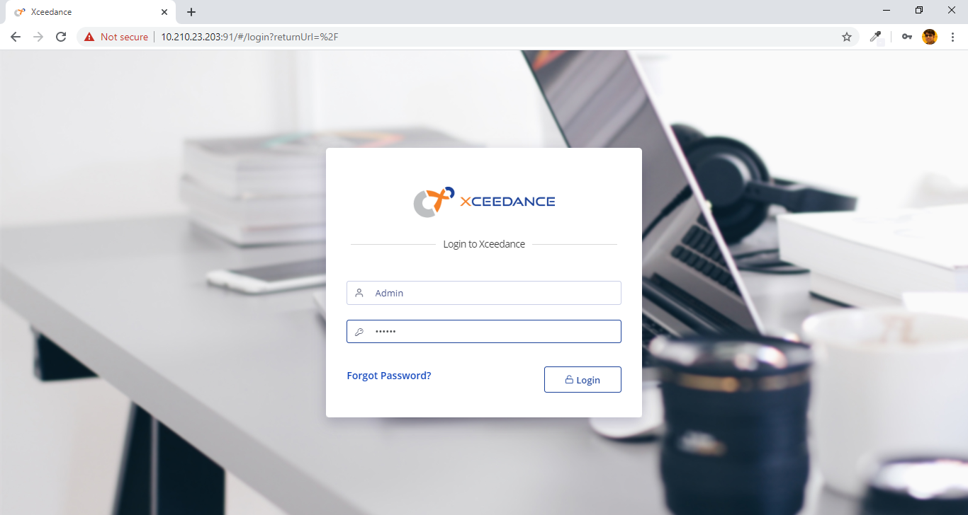

* The user land to the Home/Dashboard page. On home page the widgets will be displayed based on the role of user. User can add more reports from Dashboard items using drag and drop.

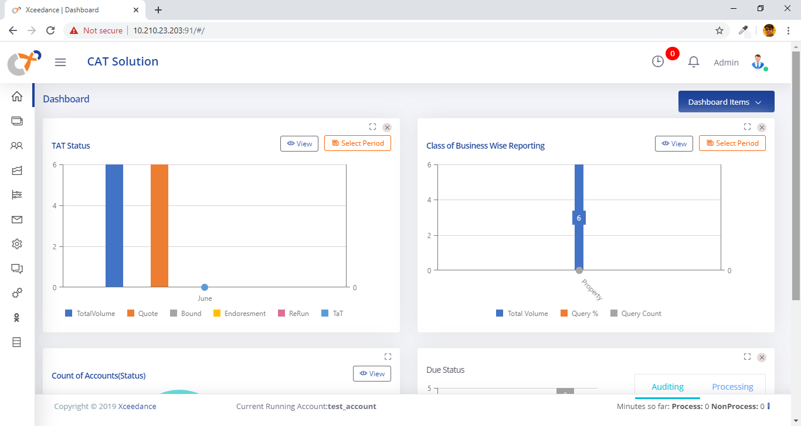

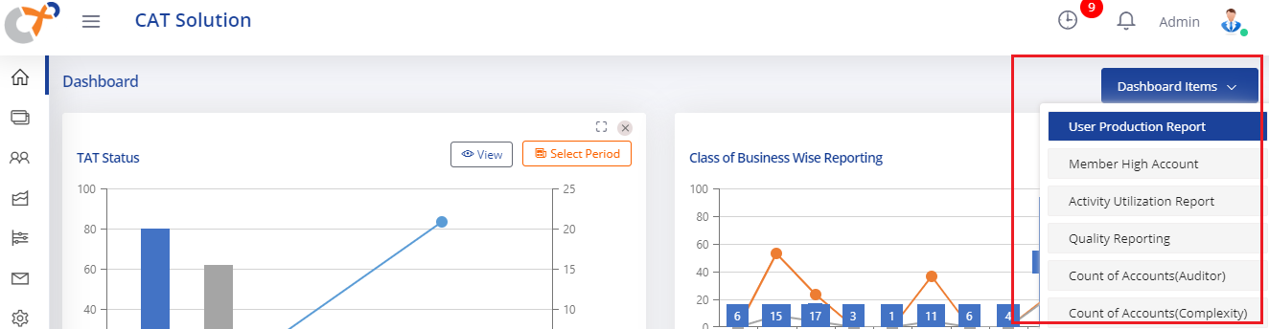

* User can zoom the report using maximize button available on widget and can also remove the widget from their dashboard using remove button.

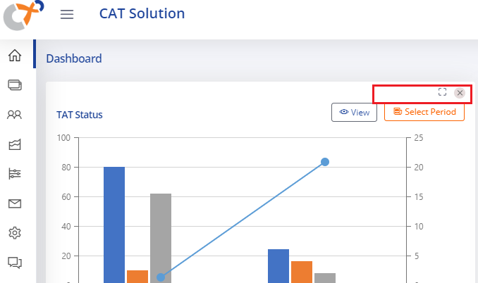

## Primary Modeling and Additional Evaluation Requests

### Create Primary Modeling New Request

* User can select the **Worktray []** option from the left side menu of the application. The respective Worktray (Job Display) page will open.

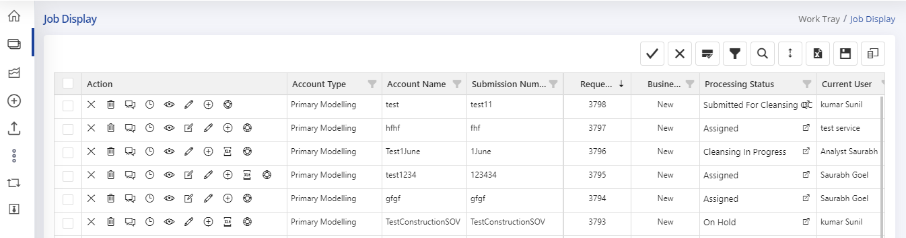

* The **“New Request []”** option will be displayed on the left side menu of application. User can make a click on this button to open the new account entry form. The Request form will be displayed along with Modelling Request Form.

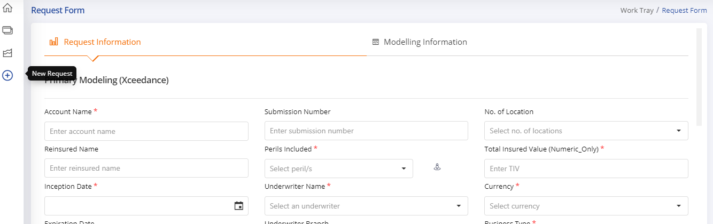

* User can fill the Request Form to create a CMR request in the CAT Solution. The request form contains the fields below (note an asterisk denotes a required field).

• **Account Name*:** Name of the account

• **Submission Number:** Submission number for the account.

**• Number of locations:** Select the number of locations in the submission from the range

provided in the drop-down.

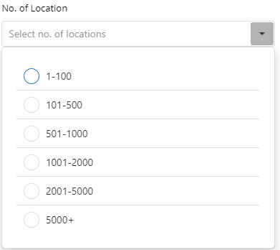

• **Perils Included*:** Users select the perils from the drop-down that needed for modeling.

The selection should match the requested perils in the Modeling Request Form (MRF).

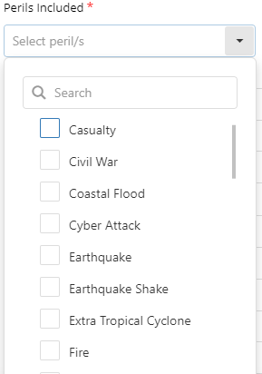

User can also save the selected perils to use in further requests. After peril selection from the dropdown the option **“Set Peril []”** will appear. User can click on the option to save selected perils into the user specific settings. In further sessions or in same session user can use **“Get Perils []”** option to select perils automatically from the user’s settings.

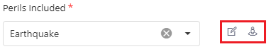

• **Total Insured Value (Numeric Only) *:** Enter the TIV of the account.

• **Inception/Expiration Date*:** Enter the inception date using the calendar, and the

Expiration Date will auto-fill for a one-year policy period. However, the Expiration

date can be manually changed to reflect policy periods of more than or less than a

year.

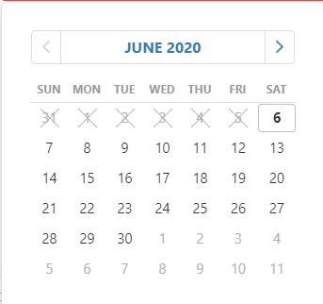

• **Underwriter Name*:** Select the name of the Underwriter from the drop-down.

• **Underwriter Branch:** Branch will be auto filled after entering the name of Underwriter.

• **Currency*:** Select the currency of the account’s reported values from the drop-down.

• **Business Type*:** Indicates whether this is a new request or a remodel. This field will be

auto-selected as “NEW” for New request and “Remodel” for remodel request.

• **Primary Modeling Due Date*:** Select from the calendar the expected delivery date for

Xceedance Primary Modeling results.

• **Request Type*:** Select the request type as per the below screenshot.

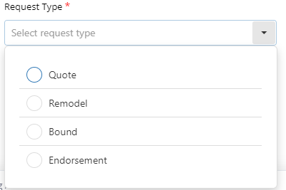

• **Line of Business*:** Select the line of business for the modeling request. Below are the

options for LOB.

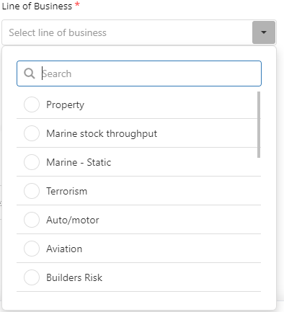

• **Priority*:** Select the priority for the request from below options. The “Medium” option will

be selected by default. User can change the option for priority.

***Note: This field will not be visible for the Underwriter and Underwriter assistant.***

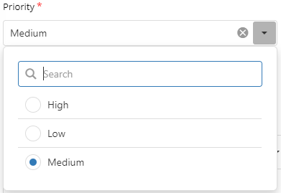

• **Platform*:** Select the platform for the request from below options. The “AIR” option

will be selected by default. User can change the Option to any other platform.

***Note: This field will not be editable for the Underwriter and Underwriter assistant.***

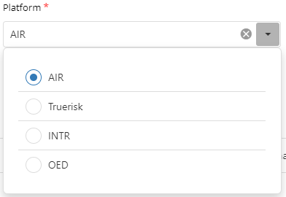

• **SOV File:** Using the fields below, the user can click “Select File” and upload the SOV by browsing for the file or dragging the file into the area labeled “Drop file here.” Alternatively, the user can copy/paste the path of the SOV in the field labeled “Enter SOV file path.” If the submission has multiple SOV files, use the Ctrl + Click to select multiple files at once when browsing for files or dropping them into the field below.

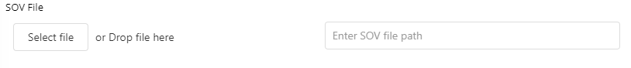

• **Account Type*:** A user can create two types of requests with the application:

o Xceedance Primary Modeling Request.

o Cat E&A Additional Evaluation Request.

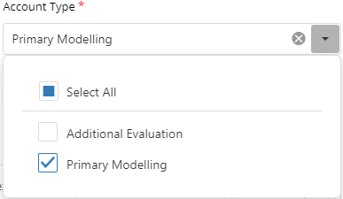

Users can create Primary Modeling and Additional Evaluation requests separately by checking the appropriate option. Alternatively, users can make both requests at one time by checking “Select All” (note that an Additional Evaluation request can also be made at any time after the user submits a Primary Modeling request).

If a user selects the request type as “Primary Modeling,” the user will see the Primary Modeling Comments section below and can use it to communicate any model request related instructions. This field is a rich-text box that allows for text, screenshots, and other images. Associated files can also be attached.

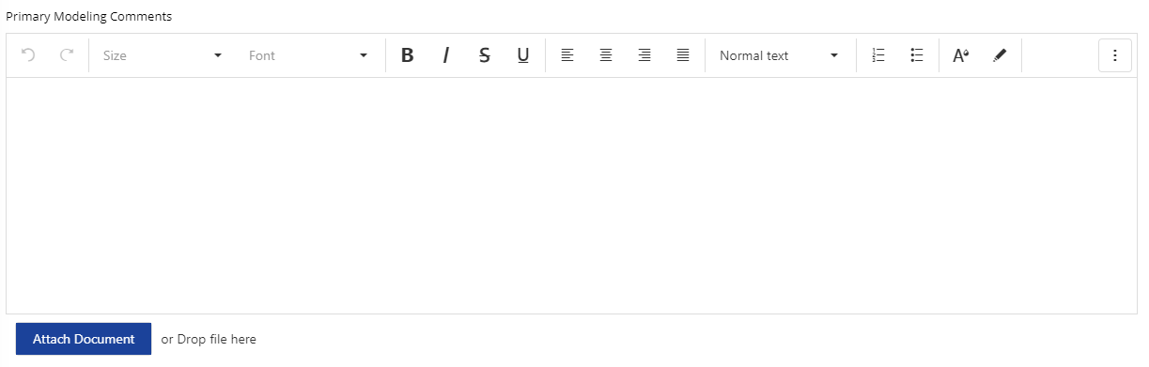

### Create Additional Modeling New Request

If the user requests an Additional Evaluation in the “Account Type,” a new set of fields below will appear. The Primary Modeling Comments will follow these fields.

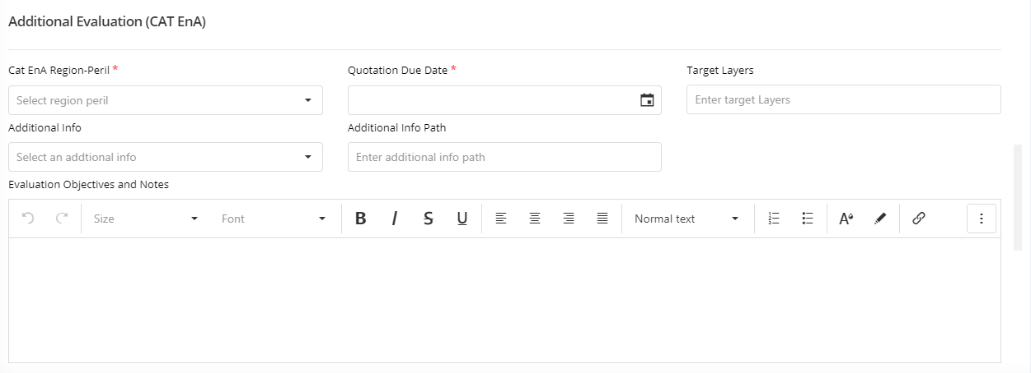

To request a Cat E&A Evaluation, the user must provide the fields described below (note a red asterisk denotes the required fields).

• **Cat EnA Region-Peril*:** Cat E&A evaluations are allocated based on the region and perils the team is evaluating. The drop-down menu below shows the region and peril combinations that dictate this work allocation.

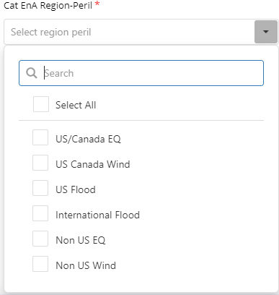

Users can choose evaluations for one or more of these region-peril combinations depending on what they need Cat EnA to evaluate (if there are any questions as to which region-peril combinations to choose, please contact CAT E&A).

When a user selects region-peril combinations for evaluation, corresponding fields that facilitate scheduling will appear in the grid shown below.

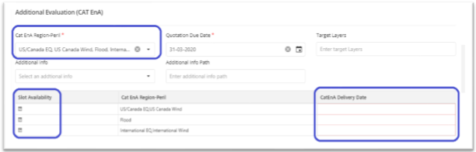

By selecting the calendar icon for each region-peril combination, users can choose a delivery date for each type of evaluation using the Due Date Availability screen shown below. Please note that there are separate capacities for each type of evaluation as the available resources and demands may differ depending on the region-peril combination. The Due Date Availability screen shows the available capacity (in terms of the number of slots) for each day. Select the additional evaluation delivery date using the “Select” button next to the available date.

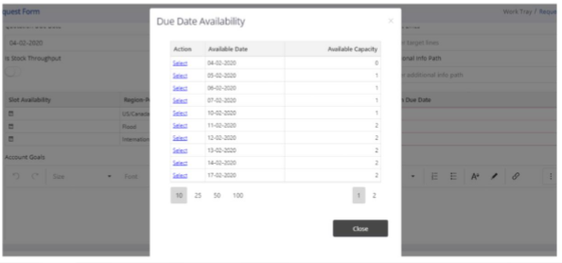

If the capacity is exhausted for the delivery date selected, the user can still submit the request as a Rush Request. A notice will pop up, indicating that the user has successfully entered a request for a date where capacity has been exhausted; however, CAT E&A will need to confirm the delivery date or coordinate an alternate date.

• **Quotation Due Date*:** Due date of Quote account.

• **Target Layers:** In cases where an underwriter is targeting one or two specific layers despite requesting more layers for modeling (e.g., renewals), providing this information would help Cat E&A provide commentary on these specific results.

• **Additional Info:** Please indicate from the drop-down if there is any supplemental information that could be useful in an Additional Evaluation (e.g., engineering reports, structural drawings, elevation certificates, etc.). If the drop-down does not include the type of supplemental information, please select “Other.” An additional field will appear where the user can describe the nature of the supplemental information.

• **Additional Info Path:** If Additional Info is specified, please copy/paste the directory path where information is stored.

• **Evaluation Objectives and Notes:** The user can provide any commentary that would be helpful in the Additional Evaluation process in this part of the form.

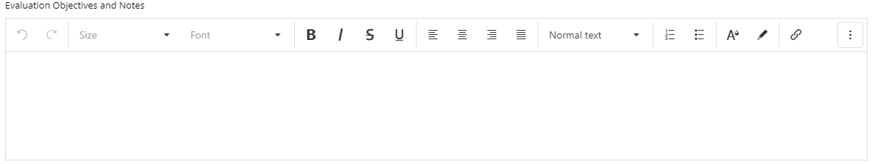

Examples of information that will help include:

o The evaluation objectives and why you would like Cat EnA to review the account

o Locations of concern

o Perils to be evaluated o Layers of most interest (if it is a renewal, current participation)

o Descriptions of information obtained o Directory path of account folder

This field is a rich-text box that allows for text, screenshots, and other images.

After filling all the necessary details, click on the Submit button.

### Request Validations and Save Draft

* If any of the required field(s) remain blank, a message window will appear with the details of the empty field(s), as shown below.

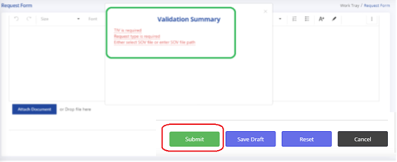

After filling the required sections, the account will be submitted and will show up in the Work tray. An email will also be automatically sent to the user confirming the request(s). If the user has a pending Rush Request for an Additional Evaluation, that will be noted in the email as well.

* User can also Save the request as a draft to submit later. User can make a click on “Save Draft” button. The current copy of request will be saved. The request will also automatically be saved on logout and session timeout during request creation.

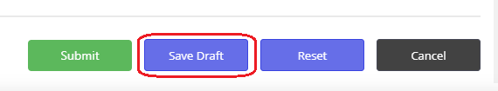

* On re-login or in same session user can see the pending request on notification icon with count of pending requests.



* User can make a click on “Pending Request []” option. A pending requests pop up will appear to select the request or discard the pending request.

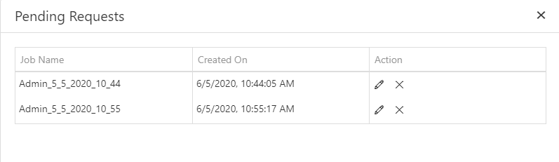

* User can Resume the request using **“Resume request []”** option. By clicking this icon, the Request Form will reopen with the fields filled out with the values previously assigned during the draft request. Here the user will be able to change or modify details such as TIV, perils required for modeling, inception/expiration date, etc.
* User can delete the pending request using **“Delete Request []”** option. The request will be removed from the Save Draft list.

## Worktray- The working area for CAT users

The Work Tray shows all active Primary Modeling and Additional Evaluation requests respective to logged in user. The information in the Work Tray allows the user to track account status, review due dates, and view other account specific characteristics.

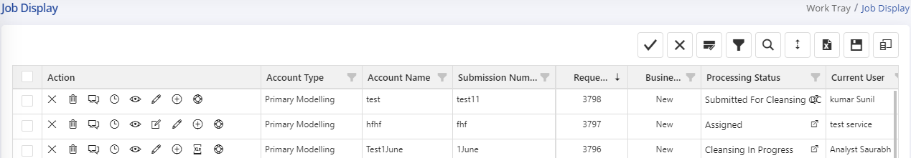

It also allows the user to take actions such as update requests, cancel requests, initiate and respond to queries, and request remodels for completed accounts. The actions on Worktray will appear based on role of user.

### Worktray User Options on Requests

At the top right of the Work Tray, several buttons help the user navigate through the accounts in the Work Tray. These icons allow the user to search for, filter and download account entries. They also can customize how a user views the Work Tray by adding and removing columns and saving filters.



* The following describes buttons that help the user maneuver through accounts within the Work Tray:

• **Column Filter  :** This option can filter accounts in the Worktray by single or multiple values contained within a column. The user can use the filter look for groups of accounts that have similar attributes.

• **Column Search :** This option can search for specific values within columns. This button can be useful when looking for an account name or date.

• **Advanced search :** This option allows users to search for an item or an account using specific fields shown below. The toolbar below will appear when clicking on this option. After choosing the search criteria, the user can click the green search button to apply that search.

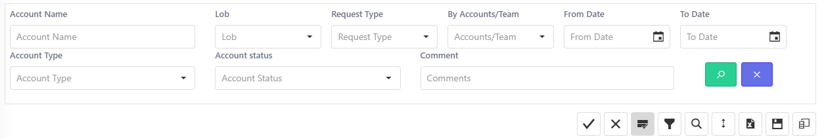

Most common uses of this option include:

o View completed accounts. By default, the tool hides completed accounts to reduce clutter in the Work Tray. The user can view them by clicking the Account Status drop-down and selecting completed accounts.

o View accounts by a specific delivery date range using the “From Date” and “To Date” fields.

• **Download accounts  :** This option extracts the information in the Work Tray into an Excel document.

• **Save Job Evaluation  :** This option used to save additional evaluation job status and user assignments in Worktray. User can change the status and users of Additional Evaluation job with in Worktray grid and save them.

* Users can customize their Work Tray using the following buttons:

• **Column Chooser ** shows or conceals any column of the work tray by using the checkboxes that appear when clicking on this icon. Select or deselect the checkboxes to add or hide columns, respectively. Column order can also be customized by dragging and dropping column headers. The user can fix columns the left or the right by right-clicking on the column header and selecting “Fix” in the ensuing drop-down.

• **Save Work Tray Settings ** will save the visible columns and the order of those columns to the user profile; these settings will persist each time the Work Tray pulls up. This feature also saves any Column Filters that the user has applied.

• **Clear Work Tray Settings ** clears all previously saved Work Tray settings and brings the work tray back to the default settings.

• **Expand screen ** maximizes the size of the Work Tray for to capture the full screen size of application. This will be helpful to visualize more data on his/her screen.

### Individual Request Options

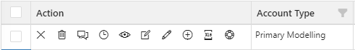

***Note: The actions related to account will appear based on the role of logged-in user and type of account.***

The panel to the left of each account entry facilitates actions that can be executed to individual accounts as follows:

* **Cancel Request ** This option allows the user to cancel the request if no further processing is required.
* **Delete Request**  This option allows the user to delete the request if the request is not required for CAT modeling. The confirmation dialog will appear before deleting the account from the application.
* **Query Log ** This option allows the user to initiate, view, and reply to queries raised by the modeling team. See section ( Query Management ) for more details.
* **View Record Time** This option allows the user to view record time spent on the process to perform various tasks. The new page will appear to display information related to time spent on account.

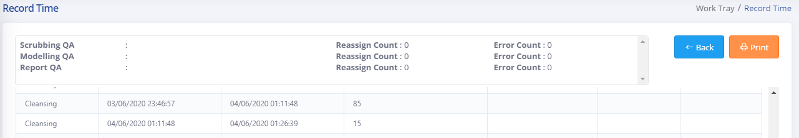

Apart from time, this page will also provide the information related to auditing of accounts like reassign count, Error count etc. User can also print the information.

* **View Process Details **This option shows a summary of the details of the modeling/evaluation request. User can also take a print of summary.

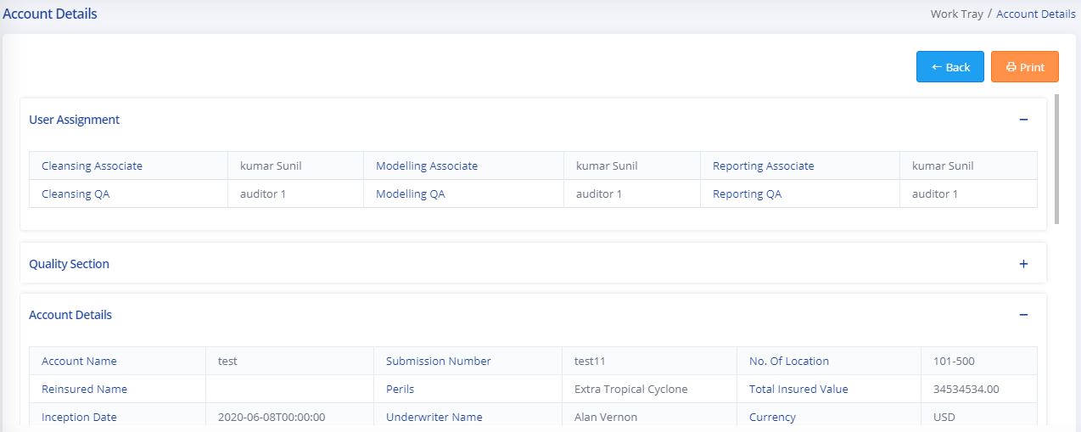

The main sections in account details are:

* + User Assignment: Information about users who are working on this account.
  + Quality Section: Information about TAT, Internal Errors and External Errors.
  + Account Details: Request summary of all fields submitted by user.
  + Additional Evaluation Details: Summary of additional evaluation fields.
  + MRF: Summary of raised MRF.
* **Update Request ** This option allows the user to modify the account. By clicking this icon, the Request Form will reopen with the fields filled out with the values previously assigned during the original request. Here the user will be able to change or modify details such as TIV, perils required for modeling, inception/expiration date, etc. This icon is only available until the modeling process begins on the account. Once modeling commences, the user can no longer modify the request.
* **Process Configuration** This option allows user to assign process related configuration before begins the tasks on that.
* **Add Additional Evaluation ** This option can make an Additional Evaluation request of an account already submitted for Primary Modeling. By clicking this icon, the Request Form will open with Account Type auto selected as “Additional Evaluation.” The user will only have to fill in the fields in the Cat E&A Additional Evaluation section (note that this option only appears for Primary Modeling requests).
* **Add Remodel Request** This option appears only on completed accounts. This option can make a remodel request of an account already completed. By clicking this icon, the request form will open with Request Type as “Remodel”. The user will only have to fill only required information like remodel reasons etc. For more details see section (Remodel Requests).
* **Account Documents** This option allows users to see documents attached to the request. By clicking this icon, the new popup will open with documents associated to the request. User can click on individual document and download it.

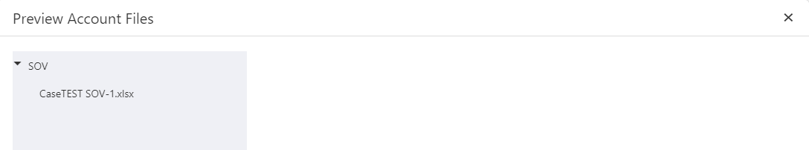

* **Update Proposed Date **This option allows user to modify the proposed date for the request. By clicking this icon, a popup will appear with date control. User can change the date and save the proposed date.

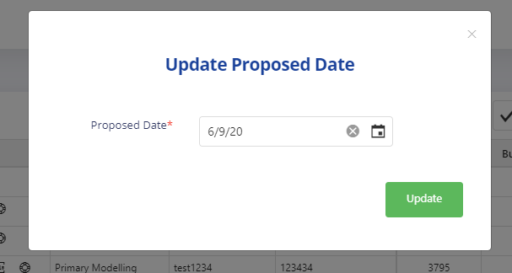

* **Assign/Update Status** This option allows user to update status and users for additional evaluation account. This option will be visible only for Additional Evaluation account type. By clicking this icon, a popup will appear with options related to status and users. Refer section “Additional Evaluation account process” for more details.

### Workflow Tasks on Request

On request selection [] the associated tasks will appear in right side of the application. User can perform various tasks associated to the request.

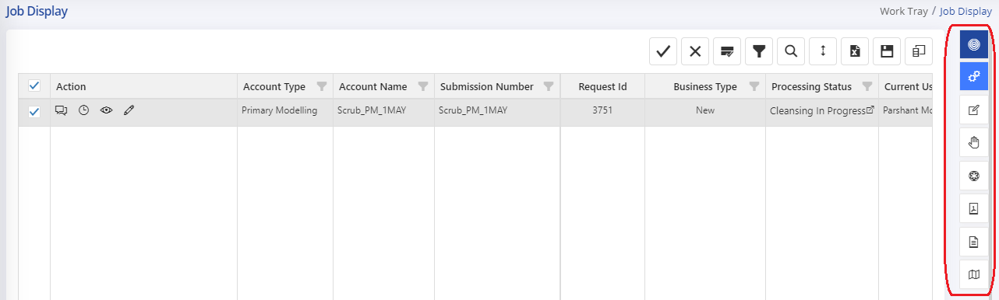

#### Cleansing Process

The Cleansing [] option will appear in tasks. User can make a click on Cleansing button. The Subtasks associated to cleansing will appear based on user role.

* **Start Cleansing Process [****]:** This option allows users to start the cleansing process. The system logs the time to start cleansing process and the account status set to “Cleansing in Progress”.
  + The Scrubbing tool will be launched if it is integrated with the application. The user can process SOV for further cleansing process. Please refer section (Scrubbing Tool ) for more details.
* **Submit Cleansing for Auditor [****]:** This option allows users to stop the SOV cleansing process. The processor can submit the request for cleansing auditing. The system logs the time to stop the cleansing process and the account status set to “Submitted for Cleansing QC”.
* By clicking this icon, a pop-up form will appear to fill information related to process. Few information like Number of location, Predominant occupancy etc. will be pre-filled from CMR/MRF request.

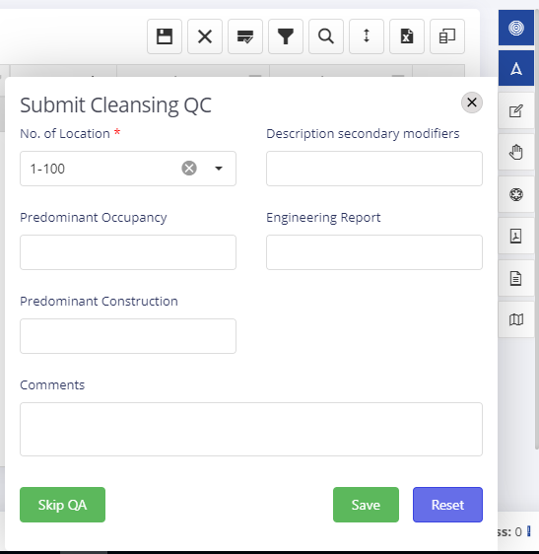

* User can also skip the auditing process using “Skip QA” button on the form. User can use this option when he/she is sure about the quality of SOV cleansing.
* By clicking on “Save” the request is submitted for QC Process.
* **Start Cleansing QC Process [****]:** This option allows users to start the QC Verification process for selected account. The system logs the time to start the QC verification process and the account status set to “Cleansing QC in Progress”.
  + The Scrubbing tool will be launched if it is integrated with the application. The user can audit the cleansing process in scrubbing tool. Please refer section (Scrubbing Tool ) for more details.
* **Approve/Reject the Cleansing Process [****]:** This option allows users to complete the QC verification process. The system logs the time to stop the QC verification process and the account status set to “Cleansing QC Completed” or “Assigned” based on Approve/Reject.
  + By clicking this icon, a pop-up form will appear to fill information related to process. User can approve/reject the cleansing by providing errors and comments.
  + User can not reject the account without selecting any error on page.

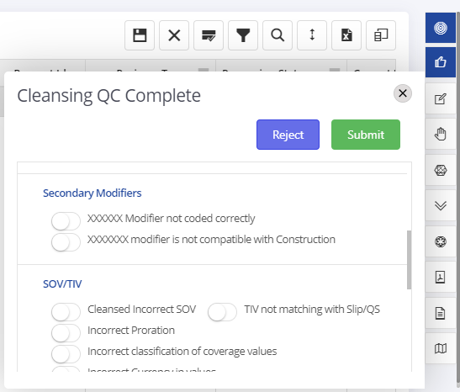

#### Modeling Process

The Modeling [] option will appear in tasks. User can make a click on Modeling button. The Subtasks associated to modeling will appear based on user role.

* **Start Modeling Process [****]:** This option allows users to start the modeling process. The system logs the time to start modeling process and the account status set to “Modeling in Progress”.
* **Submit Modeling for Auditor [****]:** This option allows users to stop the modeling process. The processor can submit the request for modeling auditing. The system logs the time to stop the modeling process and the account status set to “Submitted for Modeling QC”.
* By clicking this icon, a pop-up form will appear to fill information related to process. (Red asterisk shows the mandatory fields to be filled before submitting)

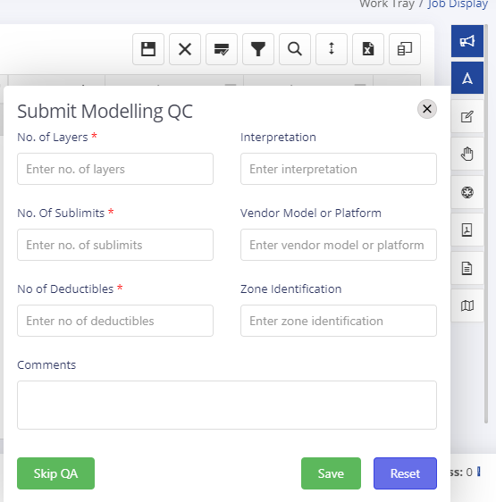

* User can also skip the auditing process using “Skip QA” button on the form. User can use this option when he/she is sure about the quality of modeling.
* By clicking on “Save” the request is submitted for modeling QC Process.
* **Start Modeling QC Process [****]:** This option allows users to start the QC Verification process for selected account. The system logs the time to start the QC verification process for the modeling and the account status set to “Modeling QC in Progress”.
* **Approve/Reject the Modeling Process [****]:** This option allows users to complete the QC verification process for modeling. The system logs the time to stop the QC verification process and the account status set to “Modeling QC Completed” or “Cleansing QC Completed” based on Approve/Reject.
  + By clicking this icon, a pop-up form will appear to fill information related to process. User can approve/reject the modeling by providing errors and comments.
  + User can not reject the account without selecting any error on the page.

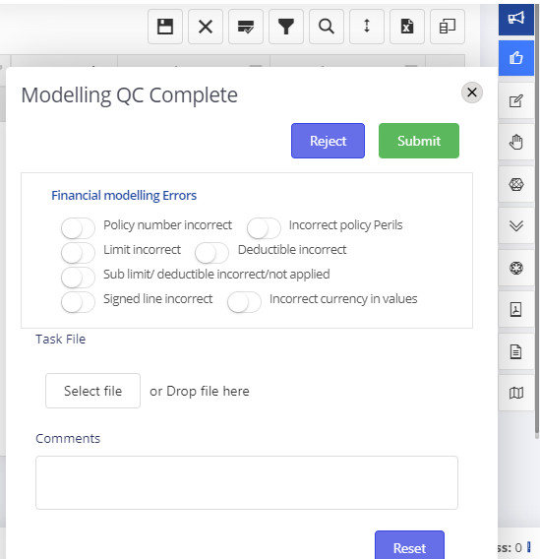

#### Reporting Process

The Reporting [] option will appear in tasks. User can make a click on Reporting button. The Subtasks associated to reporting will appear based on user role.

* **Start Reporting Process [****]:** This option allows users to start the reporting process. The system logs the time to start reporting process and the account status set to “Report in Progress”.
* **Submit Reporting for Auditor [****]:** This option allows users to stop the reporting process. The processor can submit the request for reporting auditing. The system logs the time to stop the reporting process and the account status set to “Submitted for Reporting QC”.
* By clicking this icon, a pop-up form will appear to fill information related to process.

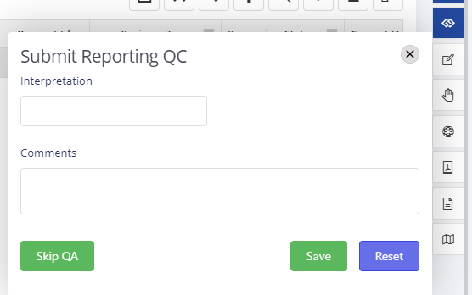

* User can also skip the auditing process using “Skip QA” button on the form. User can use this option when he/she is sure about the quality of reporting.
* By clicking on “Save” the request is submitted for reporting QC Process.
* **Start Reporting QC Process [****]:** This option allows users to start the QC Verification process for selected account. The system logs the time to start the QC verification process for the reporting and the account status set to “Report QC In Progress”.
* **Approve/Reject the Reporting Process [****]:** This option allows users to complete the QC verification process for reporting. The system logs the time to stop the QC verification process and the account status set to “Report QC Completed” or “Modeling QC Completed” based on Approve/Reject.
  + By clicking this icon, a pop-up form will appear to fill information related to process. User can approve/reject the reporting by providing errors and comments.
  + User can not reject the account without selecting any error on the page.

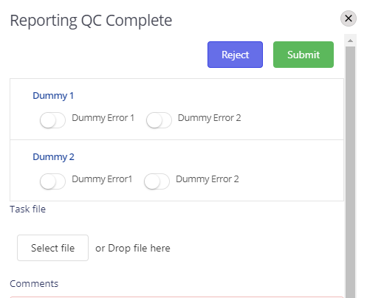

#### Other Processes

* **Query Resolution [****]** This option allows users to provide time spent on query resolution of an account. By clicking this icon, a Pop-up will appear to get time spent on account. User can save the time by click on “Save” button.

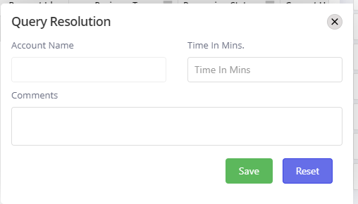

* **On Hold [****]** This option allows users to put account on Hold. The status of account will be set to “On Hold”.
* **Fill Complexity Matrix [****]** This option allows users to fill complexity of account. By clicking this icon, a pop-up will appear to fill the relevant information. User can fill the information related to account complexity and save.

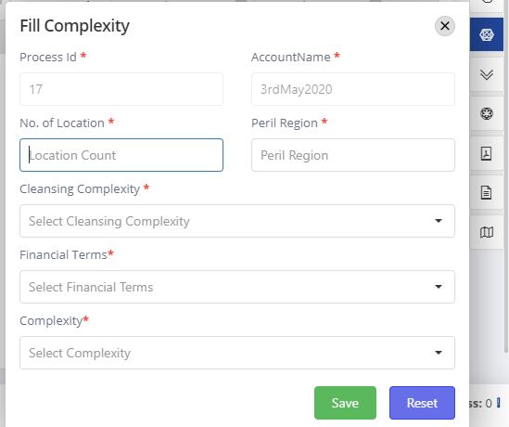

* **Move Account [****]** This option allows users to move account from one team to another team in case the capacity is not available with in that team to complete the tasks. By clicking this icon, a pop-up will appear to select another team. User can select the team and click on save.

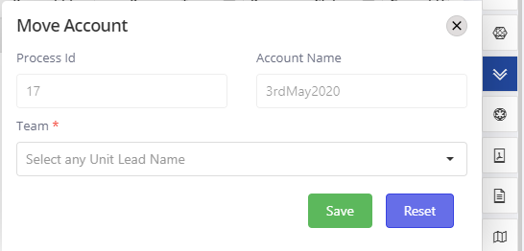

* **Risk Inspection [****]** This option allows users to provide time spent on risk inspection of an account. By clicking this icon, a Pop-up will appear to get time spent on account. User can save the time by click on “Save” button.

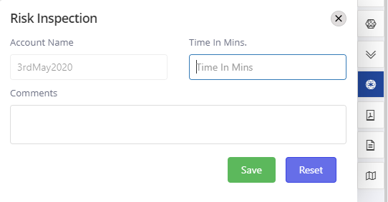

* **PDF Extraction [****]** This option allows users to provide time spent on PDF extraction of an account. By clicking this icon, a Pop-up will appear to get time spent on account. User can save the time by click on “Save” button.

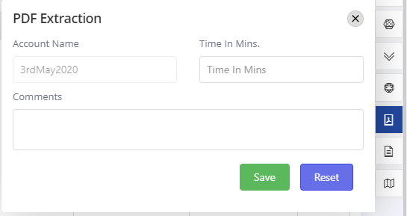

* **Process Documentation [****]** This option allows users to provide time spent on process documentation of an account. By clicking this icon, a Pop-up will appear to get time spent on account. User can save the time by click on “Save” button.

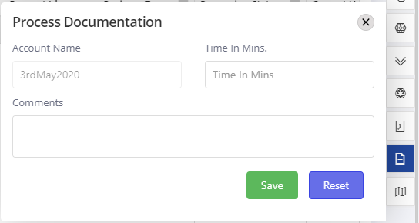

* **Geospatial [****]** This option allows users to provide time spent on geospatial of an account. By clicking this icon, a Pop-up will appear to get time spent on account. User can save the time by click on “Save” button.

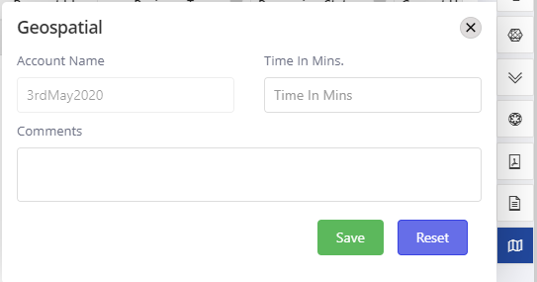

* **Complete Account [****]** This option allows users to complete the selected account. By clicking this icon, a pop-up will appear with option to send notification through mail and option to set the complete date in case needs to change from current date. By default the mail sent to the associate Underwriter.

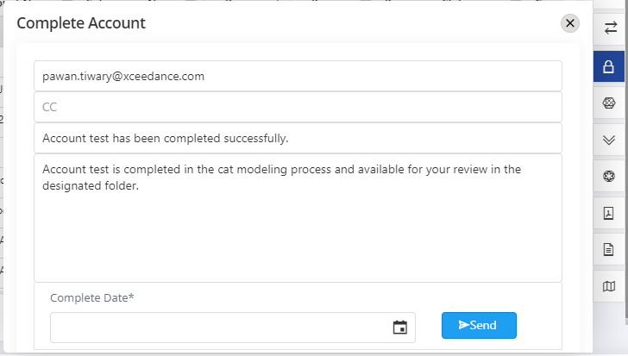

* **Delegate Activity [****]** This option allows users to delegate the activity to other users By clicking this icon, a pop-up will appear to select Parent Task, Task Name and Analyst name to assign subtasks. After making proper selection user can make a click on Save to assign subtasks to another user.

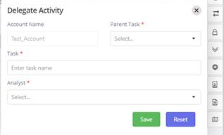

### Non-Production Tasks

* **Other Activities [****]** This option will appear on left hand menu of Worktray. This allows users to provide time spent on other activities like meetings, trainings etc. By clicking this icon, a pop-up will appear to get time spent on other activities. User can select the appropriate Task category and time spent on that and make click on Save.

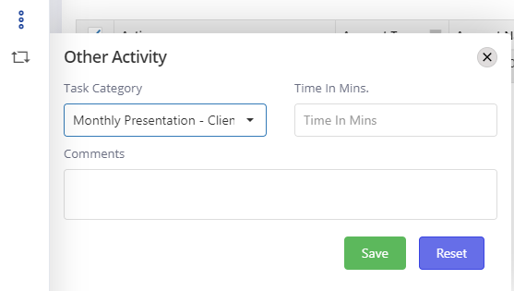

## Remodel Requests

The user can only make remodel requests on completed accounts. By default, the Work Tray shows only active modeling requests and hides completed accounts. To submit a remodel request, follow the steps below:

* On the Work Tray, click Advanced Search  on the right side of the screen. A search panel will appear at the top with several fields.
* Under the Account Type, select “Primary Modeling.”
* Under the Account Status, use the drop-down to select “Completed” and click the green search button. The application will search the database for completed Primary Modeling requests and pull them up in the Work Tray.

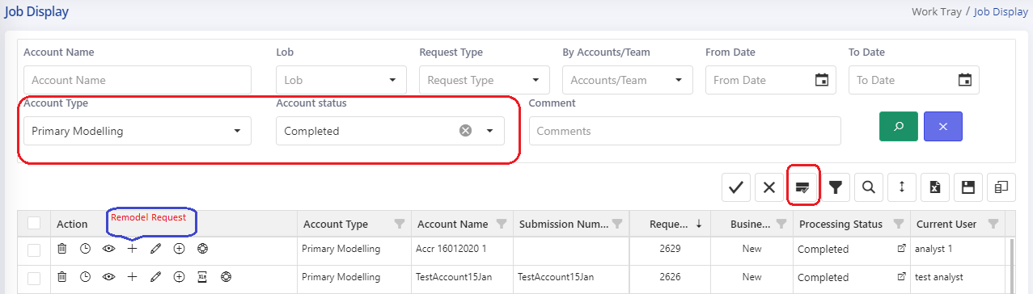

* An additional icon  will appear in the Action tray for completed accounts. Click on this icon to open the request form (this will have all the details entered while making the original modeling request).
* In the Remodel Request form, an additional field, “Remodel Reason,” will be visible, and the user can select the remodel reason from the drop-down, as shown below. The Due Date and SOV path/file are also required fields for a remodel.

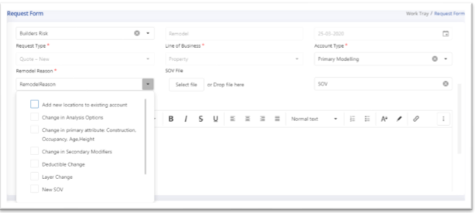

* If you also need a remodel for an associated Cat E&A Additional Evaluation, click on Account Type and check “Additional Evaluation” (same as a new request, see Section Create Additional Modeling New Request).
* After all the required fields are updated, the user can click “Submit” to make the remodel request. The remodel request will then be visible in the Work Tray with the “Business Type” as Remodel.

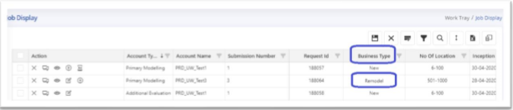

## Query Management

The Xceedance Cat Modeling Team may have a question for the Underwriter to address before modeling can continue. In these cases, the Cat Modeling Team will raise a query directly through the application. The Cat Modeling Team’s questions will be visible in the Query Log.

* A notification will appear at the top right of the interface when the Cat Modeling Team raises a query.

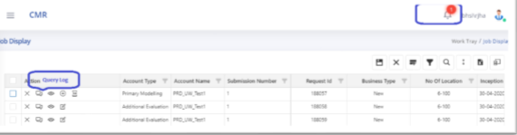

* The user can click on the query log icon, and this will take the user to the query log, as shown below:

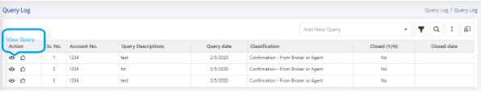

From here, the user can click on the View Query icon, which will take the user to the body of the query.

* The user can reply to the query directly from the application using the reply option, as shown below:

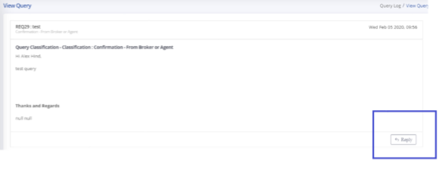

* When the Cat Modeling team raises a question, the system will also send an email to the Underwriter automatically. If preferred, the Underwriter can reply to the email instead of responding through the application.
* A user can also initiate a query to communicate any additional information to the Cat Modeling team.

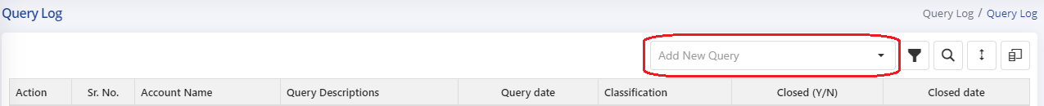

* The user can execute a query by clicking on the Add New Query drop-down on the top right of the Query Log and selecting a Query subject. The query classification as below:

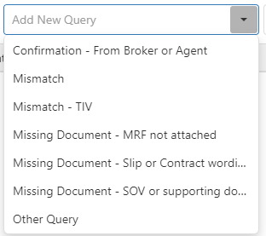

* Once a classification is selected, New Query page will appear, allowing the user to enter their message and recipients.

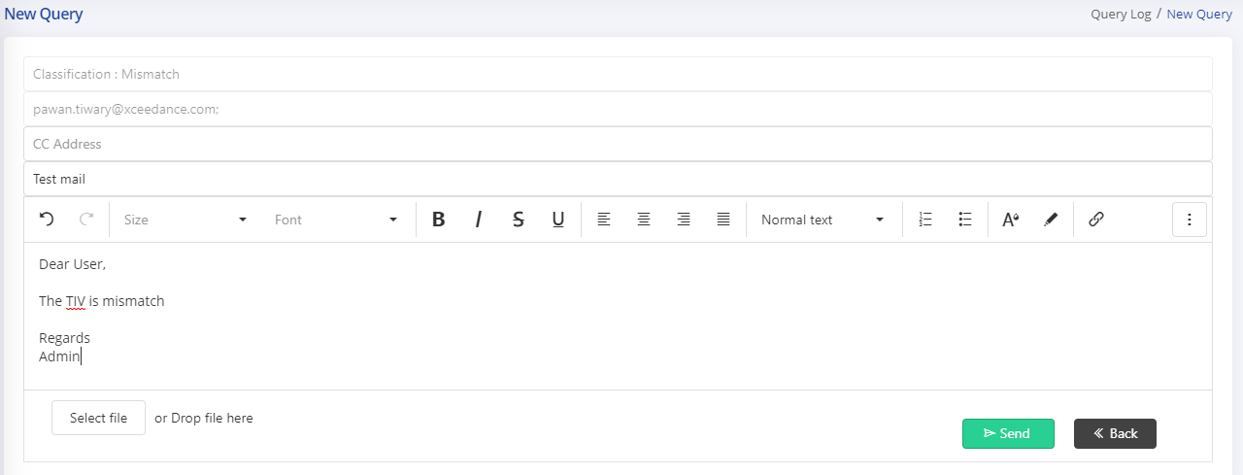

* User can also attach the support files for the query. Once user is ready with his/her query, he/she can click on “Send” to raise a query for selected request. Validations will be performed for Subject and content for mail as well on send click.

## Application Configuration

* Admin User can select the option “**Configure App []**” from the left-hand menu of the application. The Application configuration page will be open.

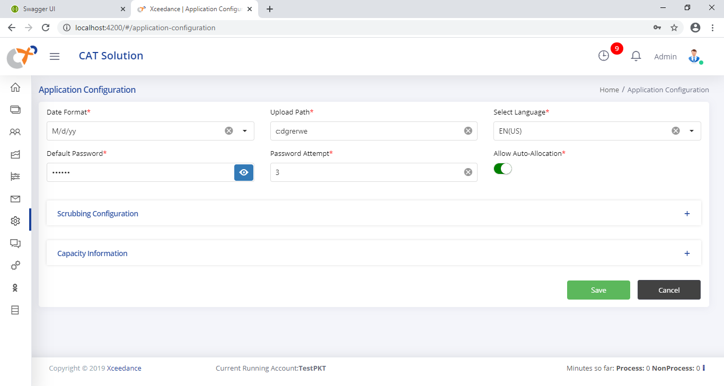

* User can provide below information to configure the application and “Save” the configuration.
  + **General:** 
    - **Date Format**- To display data in selected format throughout the application
    - **Upload Path**- Path of server where all documents can be stored
    - **Language**- As of now supporting only English
    - **Default Password**- Password for the application for all users.
    - **Password Attempt**- Login attempt for the User.
    - **Auto Allocation**- On/Off for application
  + **Scrubbing Tool Configuration:**
    - **Hazard Data**- On/Off for Third party API to improve quality of location data
    - **Prediction**- On/Off the Machine Learning to predict the Column Mappings and Primary modifiers mappings.
    - **Prediction Meter**- Set the prediction value to select option automatically on Column Mapping and Modifiers Mappings. If the ML return the prediction value more than the prediction meter value, the option will be selected by default.
    - **Geocoding**- Selected/All, based on selection geocoding will be performed.
    - **Import Model Mappings-** User can import the mappings in provided format to covert the OED data to any Model. During export this mapping will be used to convert data from OED to another model. User can import the mappings for specified LOB.
  + **Capacity Information-** This section provides the information about available capacity for different account types.

## Mail Configuration

* Admin User can select the option “**Configure Mail []**” from the left-hand menu of the application. The Mail configuration page will be open.

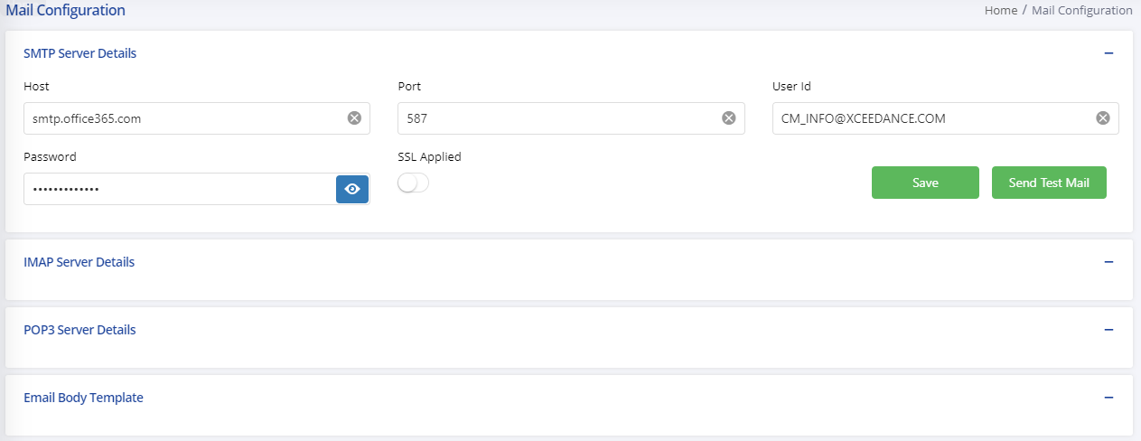

* User can configure the different mail services to make the communication through emails during query log, new requests etc. In application user can configure below mail services:
  + **SMTP:** User can provide the SMTP details of the client and save the configuration for same. User can also Send a test mail to check the connection.
    - Host
    - Port
    - User ID
    - Password
    - SSL
  + **IMAP:** User can provide the IMAP details of the client and save the configuration for same. User can also Send a test mail to check the connection.
    - Host
    - Port
    - User ID
    - Password
    - SSL
  + **POP3:** User can provide the POP3 details of client and save the configuration for same. User can also Send a test mail to check the connection.
    - Host
    - Port
    - User ID
    - Password
    - SSL

## User Management

* Admin User can select the option “**Manage User**” [] from the left-hand menu bar of application. The Manage User page will be open. The Manage user option will be mark as selected.

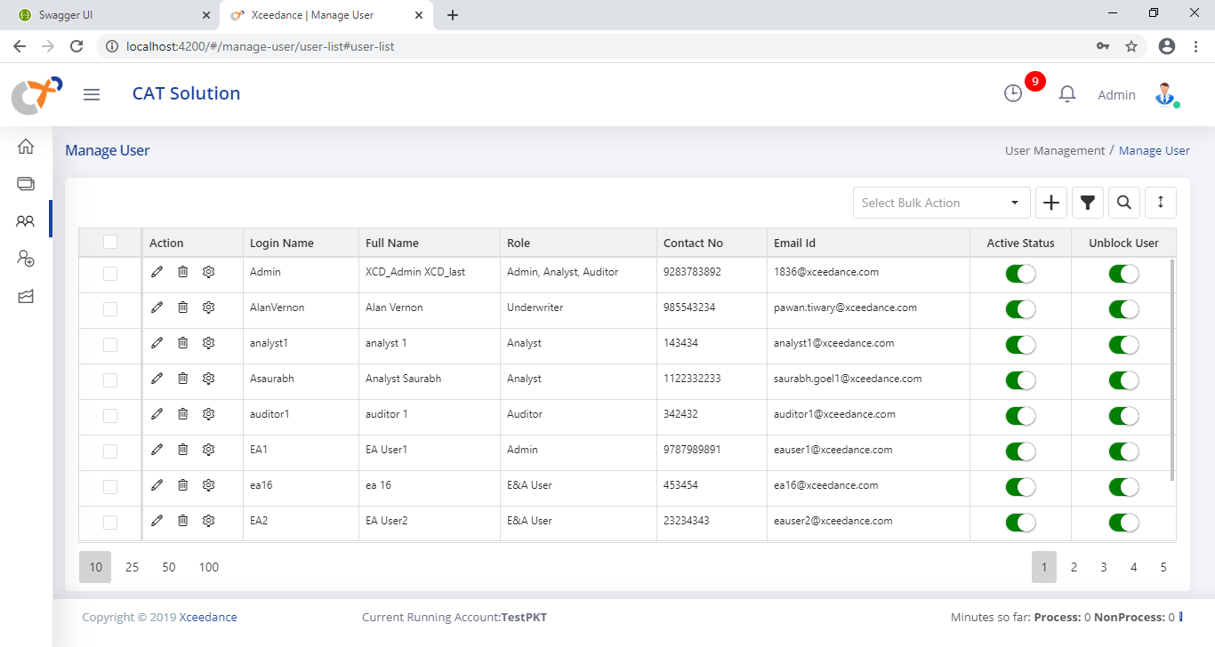

* Admin User can create a **New User** using [] button at the top right of the Manage User data. The **“New user”** page will be open with required fields to create a New user in CAT Solution.

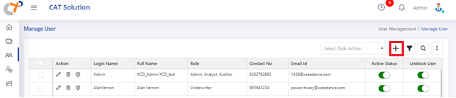

* Admin User can fill the below information and Save the User. The New user entry will be added into the Manage User page and user will get notified by success notification message.
  + **Username**- User name will be the Login name for user to login into the system.
  + **Role**- Role can be selected as provided in section 4. For Underwriter there will be another option to select associated branch. You can provide multiple roles to a user.
  + **First Name**- User first Name
  + **Last Name**- User last Name
  + **Contact Number**- User’s contact number
  + **Email**- Email ID of user. This will be used in query management system.
  + **Time Zone**- Current Time zone of the user. This will be used in data visualization where data need to be visualized in according to date and time.

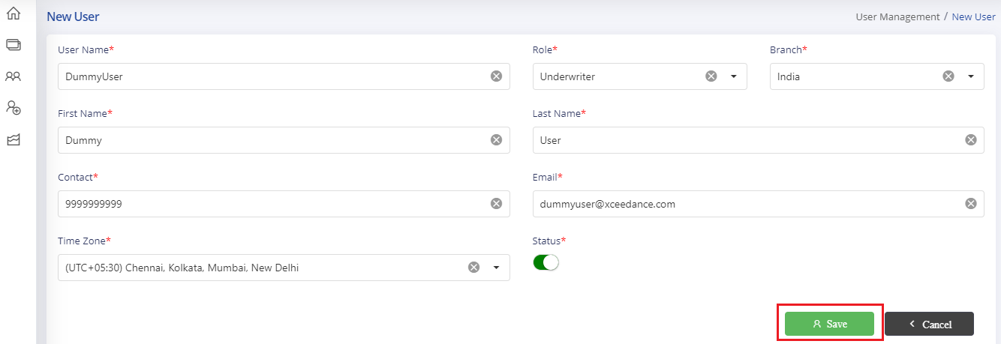

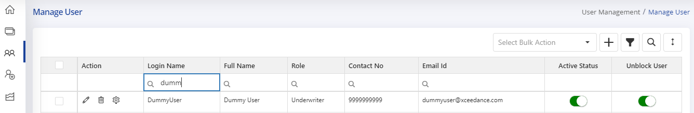

* Admin User can edit the user information using edit [] option available in action area of manage user screen. On edit click the edit user page will open with predefined data of user. The user can change the applicable information and update the user.

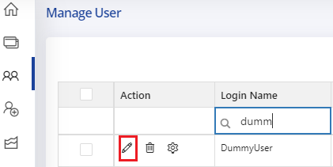

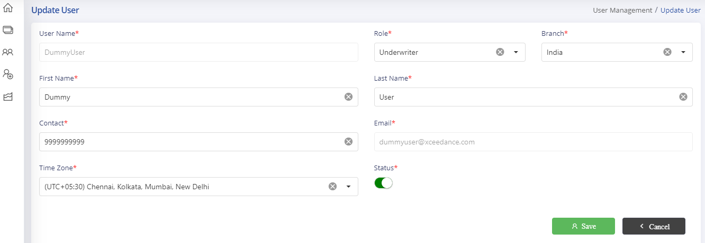

* Admin User can provide the more privileges to the application apart from the role which created by default using “**Privilege []**” button. On “Privilege” click user will moved to User Privilege page. On this page you can select and unselect the configurable features for application and Save.

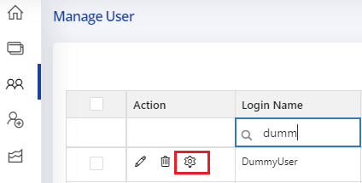

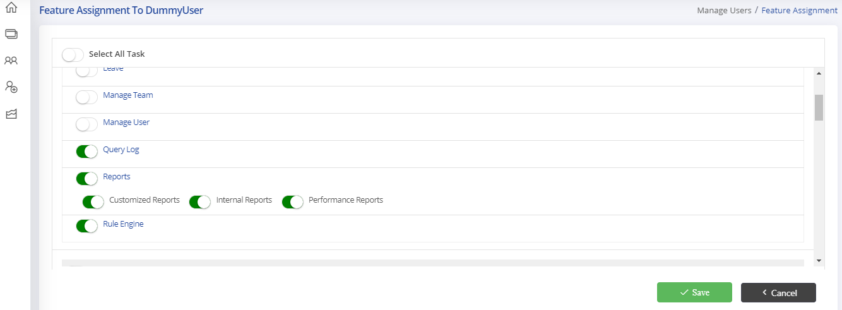

* Admin user can delete a user using **“Delete []”** option. There will be a confirmation before deleting a user. If you select “Yes” then user will be deleted from the system. Admin user can also delete multiple users using selection and Bulk Action above the data display.

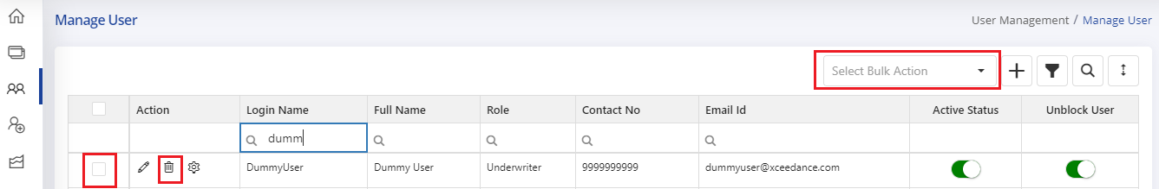

* Admin user can Block/Unblock and Active/De active the user using “Active Status” and “Unblock Users” option [].

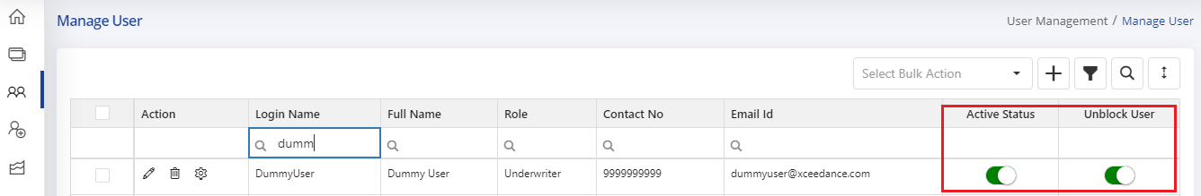

## Team Management

* Admin User can select the option “**Manage Team []**” from the left-hand menu bar in Manage User section. The Manage Team page will be open.

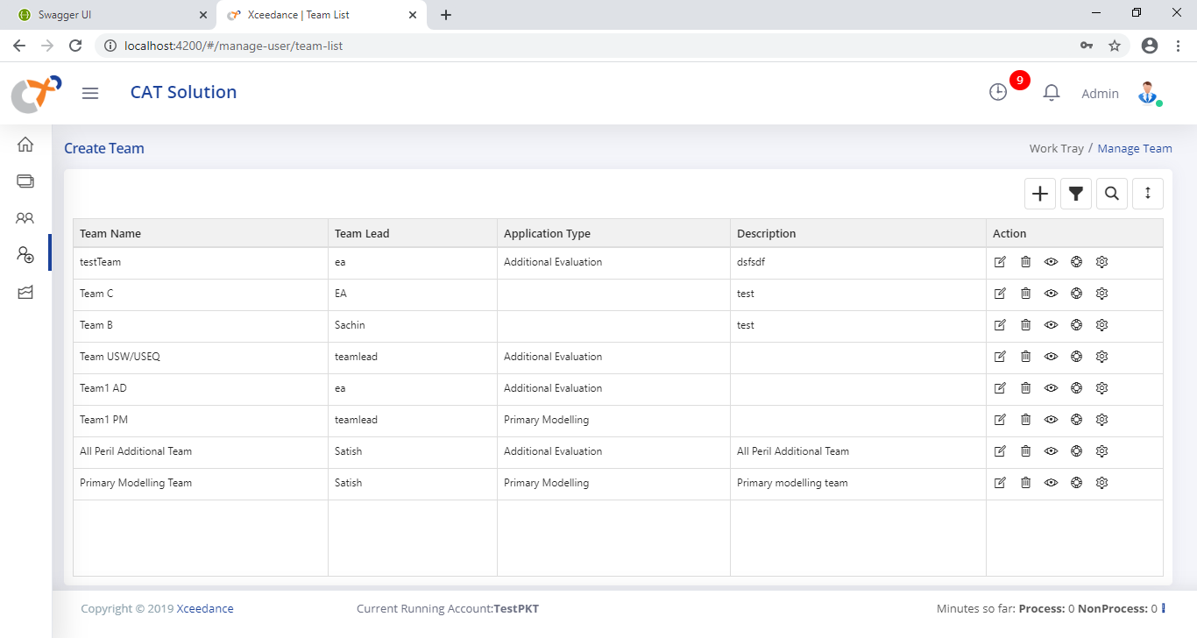

* Admin user can create a new Team using [] button available at top right corner of Mange team page. User can make a click on  button, the Create Team popup will open to get required information to create a team.

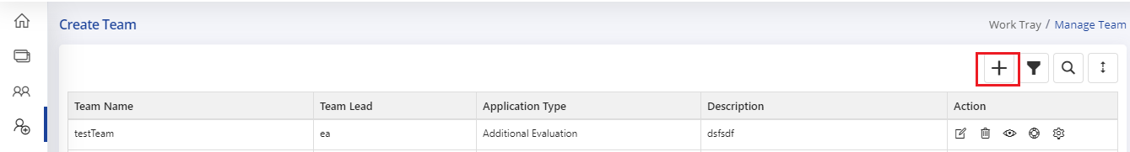

* Admin user can provide below information and make click on “Save” button to create a new team.
  + **Team Name**- Name of team
  + **Members**- Select multiple members with combination of different roles. For Primary modelling team you must select at least one Unit Lead member.
  + **Team Lead**- Select a user who have the role of Unit Lead.
  + **Capacity**- The daily limit of accounts in normal queue.
  + **Additional Capacity**- The daily limit of accounts in rush queue.
  + **Comments**- Any remarks.

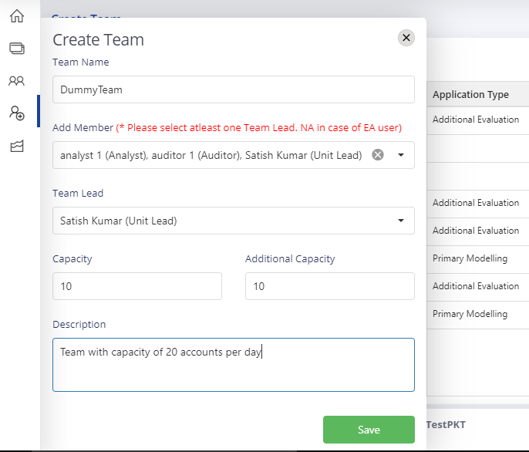

* The team will be created and display in the team list of previous page. Admin user can associate the team to “Primary Modelling” or “Additional Modelling” account type based on different criteria. Admin user can select the **“Assign Type []”** option from action panel of team.

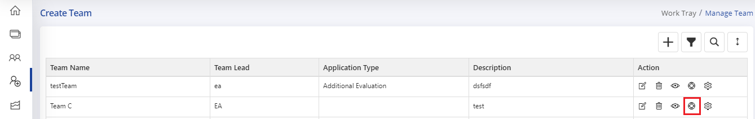

* The Assign type pop up will open to select account type and other information to associate a team with Application Type. There is below option available for different categories.
  + Primary Modeling
    - Quote/Rerun
    - Bound/Endorsement
  + Additional Modeling
    - Peril Regions

User can select the appropriate type and save the configuration.

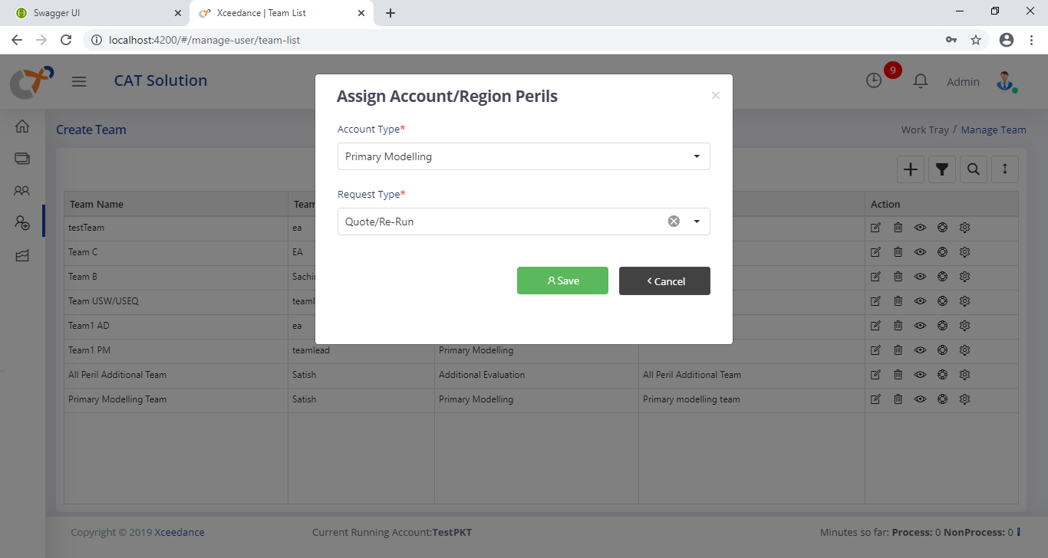

* Admin user can delete a team using **“Delete []”** option from action area of a team. The application will show a confirmation dialog before deleting the selected team. On “OK” click the Team will be deleted from the system.

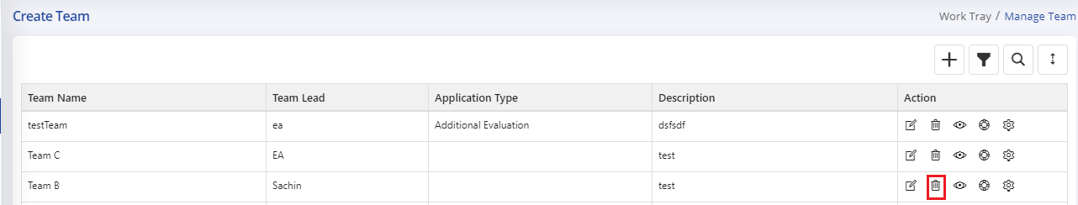

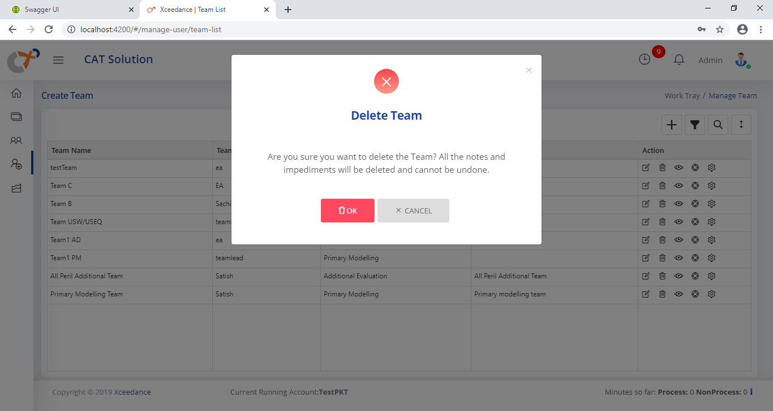

* Admin user can edit a team using **“Edit []”** option from action area of selected team. The Edit Team pop up will open with pre-filled information of the Team. The user can change the relevant information and save back the team data.

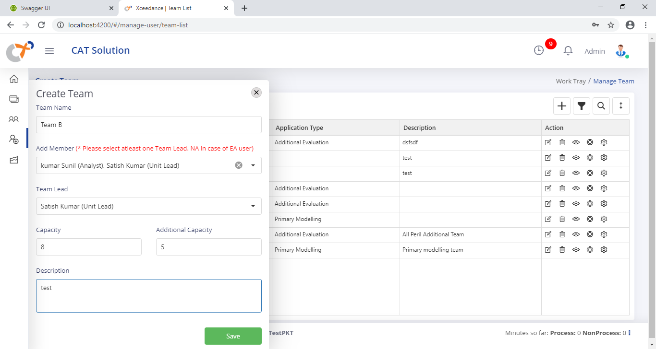

* Admin user can view the team member associated to a team using **“View Team []”** option from action area of selected team. The popup will open with the list of all team members.

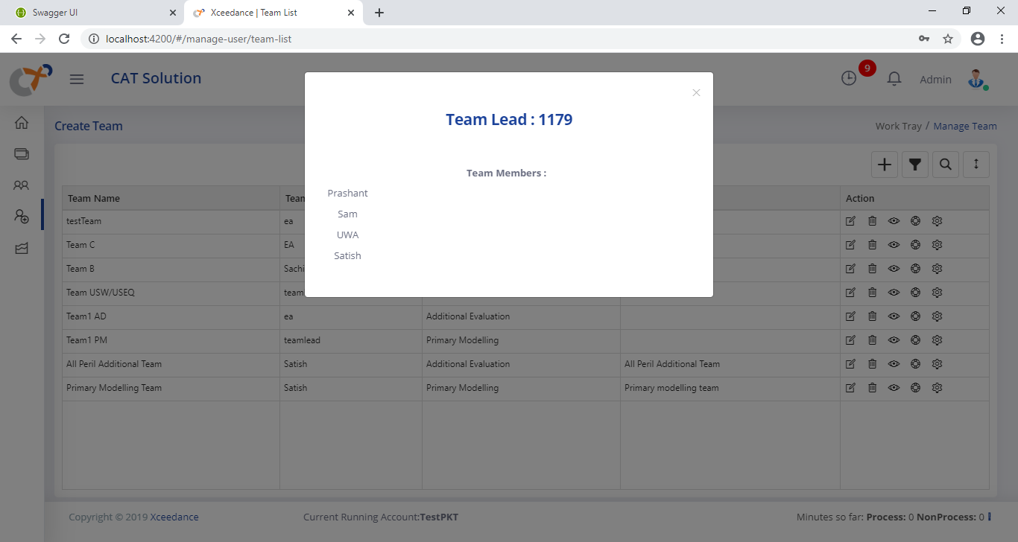

* Admin User can provide the Privilege to a team using **“Team Privilege []”** option from the action area of selected team. On “Team Privilege” click user will moved to Team Privilege page. On this page you can select and unselect the configurable features for application and Save.

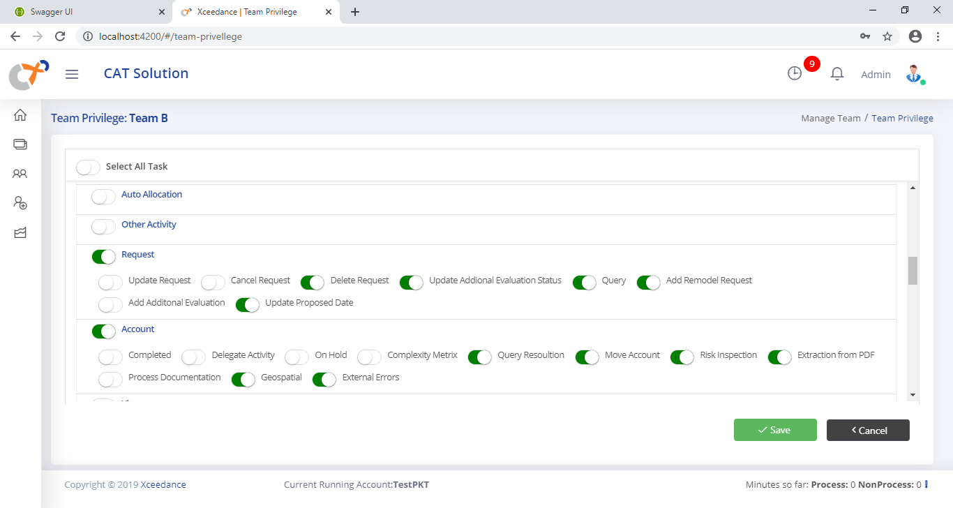

## Account Assignments

The Account assignments is used to assign work to respective users for Primary modeling. This option will appear based on user role. The Admin of application and unit lead can do the account assignment.

* User can select the **Worktray []** option from the left side menu of the application. The respective Worktray (Job Display) page will open.
* The **“Assign Work []”** option will be displayed on the left side menu of application. User can make a click on this button to open the user assignment form. The assignment form will be displayed with “Unassigned” requests by default.

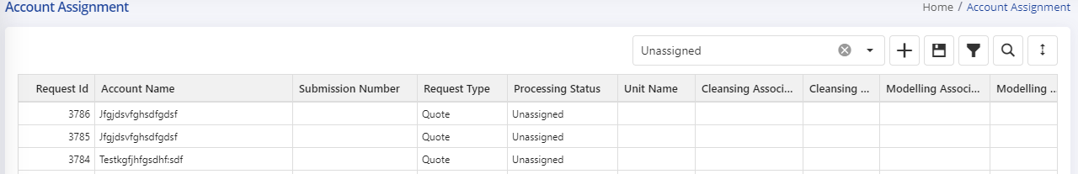

### Assignment Options

At the top right of the assignment area, several buttons help the user to navigate through the accounts in the assignment stage. These icons allow the user to search for, filter, save and auto allocate account entries. They also can filter the accounts based in Unassigned, Assigned and All.



By default, Unassigned filter applied on accounts. The User can change the option to see assigned and all accounts to change the user assignments.

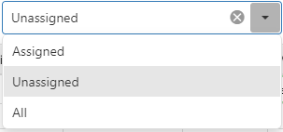

* **Assign and Save :**User can select respective users for different tasks and save the unassigned tasks using this option.

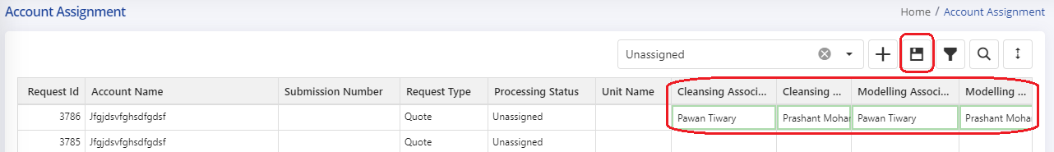

* **Auto Allocation :** This option can auto allocate/distribute the accounts to teams. By clicking this icon, the auto allocation process will start, and Unit Name field will show the name of team in which the account is allocated.
  + The respective unit lead can further assign the accounts to their respective members.
* **Column Filter  :** This option can filter the accounts in the assignment screen by single or multiple values contained within a column.
* **Column Search :** This option can search for specific values within columns. This button can be useful when looking for an account name or unit name.

## Leave Management

The Leave management is used to manage the leaves of users. This is useful while user allocate the accounts to users.

* User can select the **Leave []** option from the left side menu of the application. The respective Leave page will open. There are two section available in Leave Page (Apply Leave and Leave History)
* **Apply Leave:** User can expand the “Apply Leave” section and request the leaves for a user by selecting username and date for leave application.

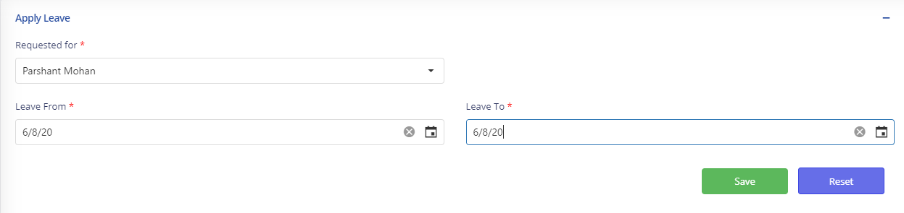

* **Leave History:** By default, the calendar view will be displayed with details of users who are on leave. The user can change the months to see the leave details.

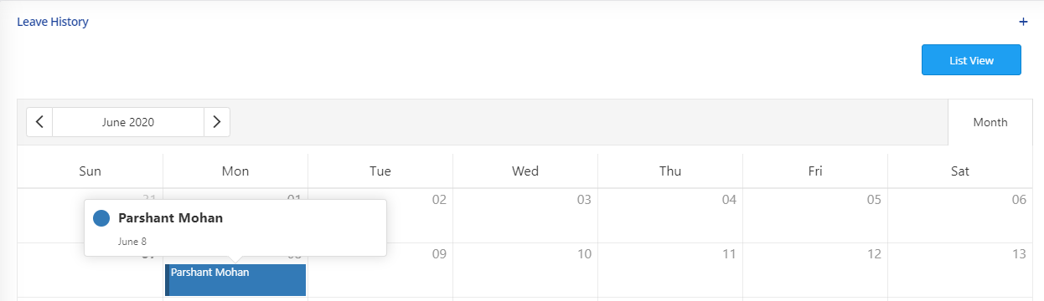

* User can change the view as List View by making click on “List View” button.

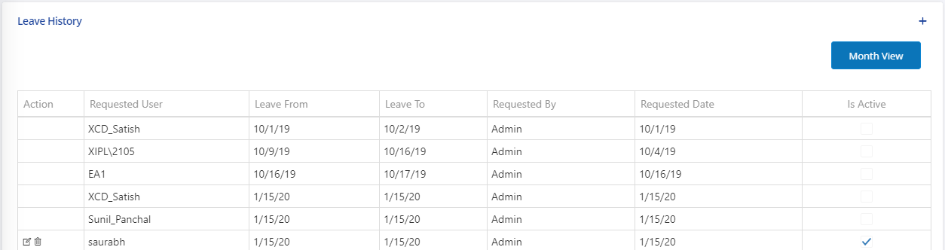

* User can discard the leave request or edit the leave request using actions [] available in List View.

## Scrubbing Tool

The Scrubbing Tool has the capability to scrubbed and cleanse the SOV files. To scrub and clean the SOV file Scrubbing Tool performs various steps.

User can make a click on [] to start the cleansing process in WFM system or on “Import Locations []” button in location management system to launch scrubbing tool.

### SOV Import

User can Import the SOV files using this page. In case SOV files are attached with in CMR request, same will appear here. The Scrubbing Tool supports .xlsx (Tabular format) and .txt formats for SOV files.

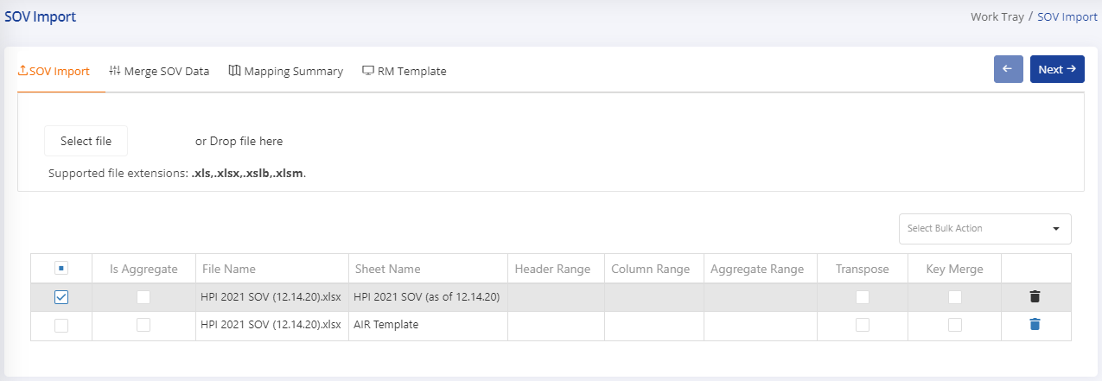

* User can click “Select File” and upload the SOV by browsing for the file or dragging the file into the area labeled “Drop file here.” The User can also select multiple SOV files.

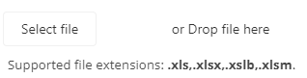

* The selected files and sheets will appear in the Sheet selection area to process further. The Sheet Selection have below fields.
  + **Select for Processing** **:** This option allows users to select one or more SOV sheets to process further for merge process.
  + **Is Aggregate:** This option allows users to select sheet for Vehicle Data processing for disaggregation.
  + **File Name:** Field display the SOV File Name
  + **Sheet Name:** Field display the SOV sheet Name available in SOV File
  + **Header Range:** This option allows users to provide range to read the headers from SOV file in case tool is not able to recognize the header from SOV file using Domain searching algorithm. This option is helpful to read multiline headers available in files. The User must provide range in format (**A1:AC1**).
  + **Data Range:** This option allows users to provide the range to read location data from SOV file in case tool is not able to recognize the data from SOV file using Domain searching algorithm. The User must provide range in format (**A1:AC84**).
  + **Delete** **:** This option allows users to delete the sheets from the sheet selection area.
* User can select the single or multiple sheets to merge SOV data to process further with cleansing process.
* The Import module provide the domain searching to identify the header in SOV and process for merge. In case the tool not able to read SOV file directly use the “Header Range” and “Data Range” features to read data from files.
* User can make a click on button to merge the selected files. Once user click on next button the merge process starts in background and user moved to the respective work area.
* Once the user gets the notification  for SOV merge successful, user can select the working account again and select the cleansing option to move to merge page of scrubbing tool.

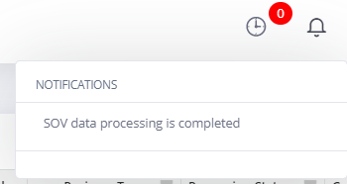

### Merge SOV Data

User can select the “Merge SOV data” tab to review the merge SOV data from the previous step. The page displays the data in grid format.

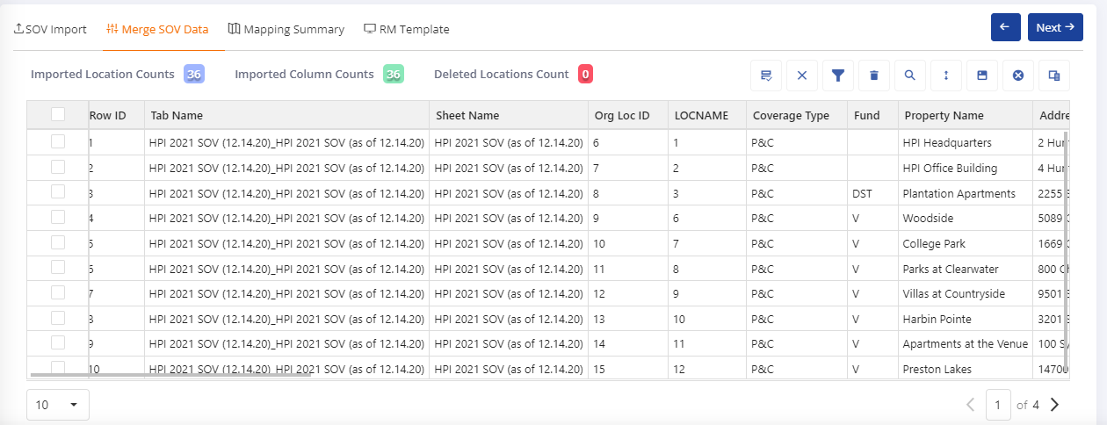

* On the Merge SOV page user can see a summary of the location data i.e., the count of location imported, count of imported column and count of deleted location having total, subtotal etc.
* Apart from original SOV data the tool appends three extra columns to identify the location number (Row ID) and associated file and sheet name (Tab Name), and associated sheet name (Sheet Name)
* During SOV reading the tool take cares for below domain cleansing of data.
  + Identify the Header for Locations data
  + Remove subtotals rows
  + Remove Totals rows
  + Remove blank or #ref rows
* On Merge SOV data page user can also delete the unwanted location in case not captured during reader process using  option on each location.
* User can also edit the location data using cell editing and save the changes from tool bar.
* User can review the data using pagination with number of locations in each page.



#### Merge Data Options

At the top right of the merge data area, several buttons help the user to perform operations like split columns. These icons allow the user to search for, filter and save location entries.



The following describes buttons that help the user maneuver through merge data:

* **Split Column**  **:** This option allows users to split a SOV columns into multiple columns. The form will appear when clicking on this option. After selecting the source column, new column name and separator if any user can click the “Split” button to split a column with copy or separator provided data into merge data.

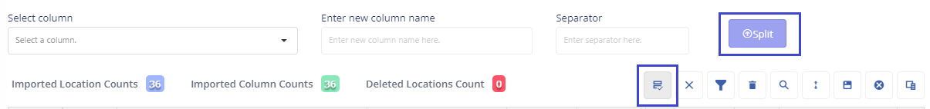

Most common uses for this option:

* + SOV file contains the multiple columns data into a single column like Latitude and Longitude data available in single column “Lat/Long” with “,” separator.
* **Column Filter** **:** This option can filter columns data in the merge data by single or multiple values contained within a column. The user can use the filter look for groups of locations that have similar attributes.
* **Clear All Filter** **:** This option can remove all the applied filter on columns data.
* **Location Delete** **:** This option allows the user to delete a location. User can delete more than one location by selecting those location and then clicking on delete location icon. This button can be useful when user don’t want to process any unwanted location data.
* **Column Search** **:** This option can search for specific values within columns. This button can be useful when looking for a location data.
* **Save Changes** **:** This option enabled once user make editing in any cell. This option allows users to save the edited changes on merge data. Once the user makes a click on this option the data will save.
* **Delete Column**  **:** This option enabled once user to delete a column. User can delete more than one column by selecting those columns from delete column popup and then clicking on delete button. This button can be useful when user don’t want to process any unwanted column data.

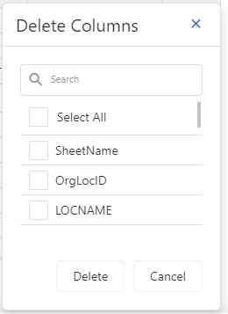

Users can customize their page using the following buttons:

* **Column Chooser**  shows or conceals any column of the merge data by using the checkboxes that appear when clicking on this icon. Select or deselect the checkboxes to add or hide columns, respectively.
* **Expand screen**  maximizes the size of the merge data screen for visualization purposes.

Once user has done with all the changes with Merge data screen, he/she can click on button to move next step (Mapping Summary) where user can map the SOV columns to Xceedance columns.

### Mapping Summary

Mapping Summary page will load with Auto Mappings from repository, from ML predictions and unmapped columns list.

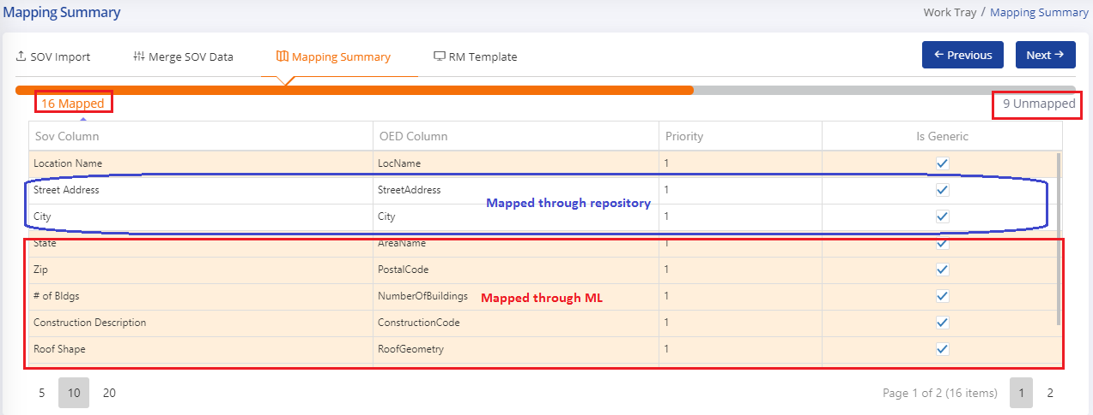

* Scrubbing tool using the in-built repository to map SOV columns to OED Columns automatically (highlighted in white color).
* Scrubbing tool leverages the Machine Learning to predict SOV columns to OED Columns.
* According to application configuration, SOV columns mapped to OED columns using prediction value higher than the configured prediction value (Highlighted in light orange color).
* The column counting bar on screen showing the status of unmapped and mapped columns.



* User can click on labels to get the Mapped and Unmapped column list respectively. Once user click on * Unmapped the screen will appear with unmapped column list.



* User can also manually map the unmapped columns to OED column with dropdown for individual SOV column in grid. The dropdown will show the top 5 options using ML predictions and rest options without predictions.

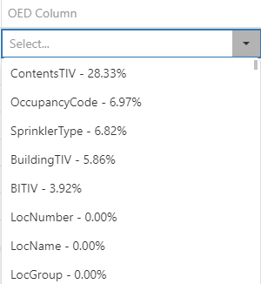

* User can also reset the value of mapped column using an option as below and choose any other OED column as per his/her best knowledge.



* User can also see the top 10 records or values of any SOV column by clicking the view icon.

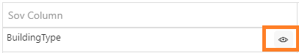

#### Set Default Values

Select Default Value [] option from left-hand menu of application on Mapping Summary page. By clicking this icon, a pop-up will appear to set default values for locations data. The default values will be used during data transformation from SOV to OED. For the below fields, if cell value is empty in SOV then the output value will be set based on provided value.

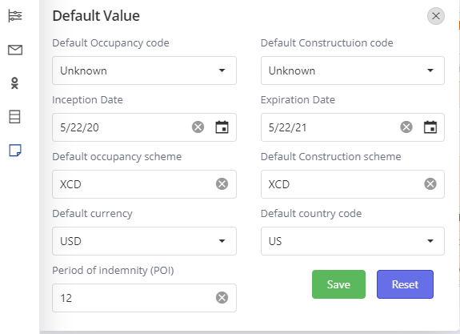

The following fields need to set in default value page:

* **Occupancy code:** User can change the occupancy code using dropdown. The default value of occupancy code is Unknown.
* **Construction code:** User can change the construction code using dropdown. The default value of construction code is Unknown.
* **Inception Date:** By default, the value set from CMR request inception date. User can update the inception date for location data.
* **Expiration Date:** By default, the value set from CMR request expiration date. User can update the expiration date for location data.
* **Currency:** User can change the default currency value for location data.
* **Country Code:** User can change the default country code for location data. USD set as a default value.
* **POI:** By default, 12 months set as a value for poi.

#### Set Priorities

User can use this option while he/she mapped the multiple SOV columns to one OED column. The System perform operations based on below conditions:

* **SUM:** If user maps multiple columns to value type OED column then system automatically do the sum of location values. In case there are “Include proration” case available in value type of columns then system create another column for the same.

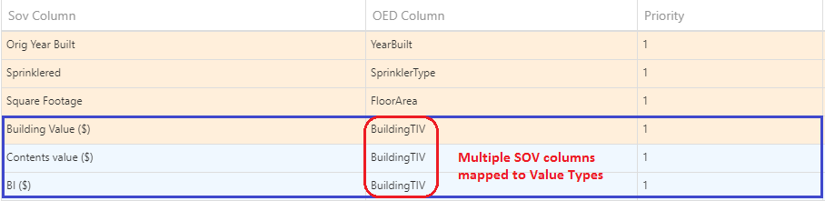

* **Concatenation:** If user maps multiple columns to OED column and set the same priority for all columns. Then system concatenate the values of all columns.

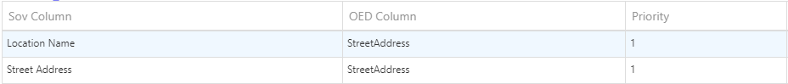

* **First Non-Empty:** If user maps multiple columns to OED column and set the different priority for all columns. The system takes the first non-empty value of column based on priority.

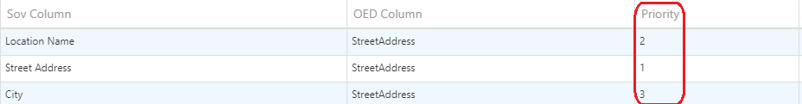

#### Generic/Specific Mappings

By default, system set as generic mappings for all columns. User can make a specific mapping for current running account in case SOV column having the values based on specific columns. The generic mappings saved in repository after auditing.

Once user has done with all the changes with Mapping Summary screen, he/she can click on button to move next step (RM Template) where user can perform data improving functions.

* By clicking on Next button, the SOV to OED columns mappings save to the system.
* By clicking on Next button, the RM Template and Scrubber process runs in background and user land to the respective work area.
* After getting the notification  for OED template and scrubber runs successful, user can select the working account again and select the cleansing option to move to RM Template page of scrubbing tool.

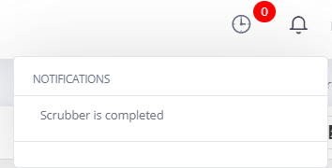

### RM Template

User can select the “RM Template” tab to move to the RM Template page. The page displays the data in grid format and associated features displayed in left hand menu of application.

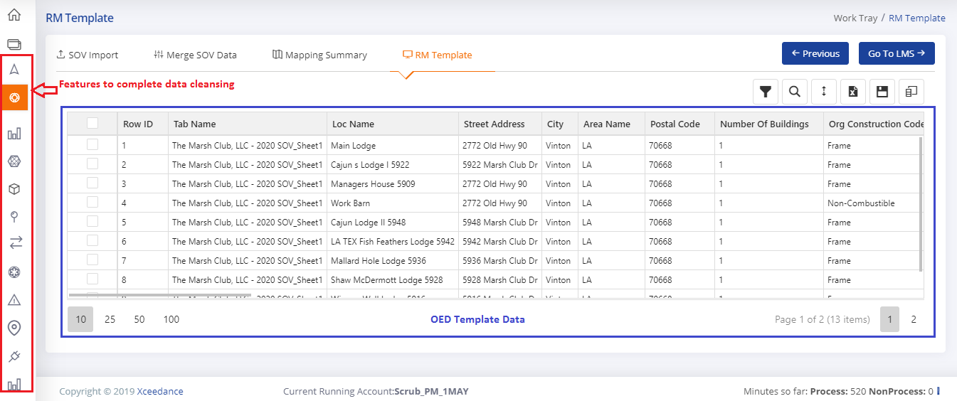

On RM template the highlighted cells indicate the invalid data for Modifiers.

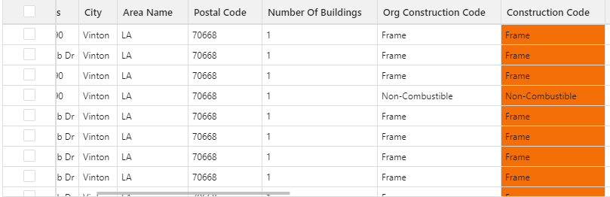

* User can perform below operations to cleanse the SOV data on RM Template:
* Geocoding
* Proration
* Polygon
* Data Validation (Sanity)
* Map Cell description to OED codes
* Annualize the data based on POI
* Show Location on Map
* Data Compare
* View Summary
* Annualization
* Export OED Template

#### Model Generation

***Note: No user intervention required to perform Model generation. It’s a system driven task which runs in background.***

The application performing below features during RM Template generation.

* SOV columns rename to OED columns based on Mappings.
* Required columns added to the RM Template.
* Cell Values for Primary and Secondary modifiers mapped to OED codes based on reference data.
* Country Name converts to Country Code using reference data.
* Postal Code length cleansing for US.
* Set default values to the cells based on OED and User Specific from Mapping Summary page.
* Get POI from SOV columns to perform annualization on BI.
* Remove last row if it is a Totals row with out any keywords for Totals/Sub Totals.
* Convert Latitude/Longitude degree values to decimal values.

#### Data Scrubber

The application runs scrubber on Address, Number of Buildings, Number of Stories, Floor Area, Year Built and Roof year built. Apart from scrubbing the system also parse the address to multiple address components for few formats of US addresses.

***Note: No user intervention required to perform scrubbing. It’s a system driven task which runs in background.***

There are few examples available for scrubbing cases.

**Number of Stories:**

|  |  |
| --- | --- |
| Original Number of Stories | Scrubbed Number of Stories |
| 1.5 | 2 |
| N/A | 0 |
| 1=4 | 4 |
| 1=2 | 2 |
| 1 & 2 | 2 |
| 1=10 | 10 |
| 6,4 | 6 |
| 3 & 1 | 3 |
| 1,2 | 2 |
| 2+ | 2 |
| 5,8 | 8 |
| 1st of 4 | 4 |
| 17 office 9 garage | 17 |
| -17 | 0 |
| 1 above ground | 1 |
| 1! | 1 |
| 1-2 | 2 |
| 3.75 | 4 |
| 1,2,3,4 | 4 |
| 1,2,& 8 | 8 |
| 1&6 | 6 |
| 1 Storey | 1 |
| 1 St | 1 |
| 1 Stor | 1 |
| 1 + 2 bas | 1 |
| 1+ 2 Basement | 1 |
|  |  |
| 110 feet | 11 |
| 90Feet | 9 |
| 80ft | 8 |
| 3/7 | 7 |
| TEN | 10 |
| Five | 5 |
| TWENTY one | 21 |

**Number of Buildings:**

|  |  |
| --- | --- |
| Original Number of Buildings | Scrubbed Number of Buildings |
| 1 | 1 |
| 1b | 1 |
| 1+1 | 2 |
| 1 Building | 1 |
| 1,2,3 | 3 |
| 1 & 2 | 2 |
| 1-2 | 2 |
| ½ | 2 |

**Floor Area:**

|  |  |
| --- | --- |
| Floor Area- Original | Floor Area- Scrubbed |
| 100Ft | 100 |
| 100Feet | 100 |
| 1 Hectare | Converted to Sq FT |
| 100 Ft. | 100 |
| 100f | 100 |
| 100#$% | 100 |
| 100Ft + 100Ft | 200 |
| 100sqFt Build + sq100Ft Parkign | 100 |
| 100 sf building | 100 |
| 100 sqft build | 100 |
| 100 sq/ft building | 100 |
| 100ft2 | 100 |
| 100f2 | 100 |
| 100sqft | 100 |
| 100sf | 100 |
| 100sf. | 100 |
| 100sqft. | 100 |
| 100 sqft | 100 |
| 100 sqft. | 100 |
| 100 sf | 100 |
| 100 sf. | 100 |
| 100 m2 | metre sq is converted to square feet |
| 100m2 | metre sq is converted to square feet |
| 100 mtsq | metre sq is converted to square feet |
| 100 msq | metre sq is converted to square feet |
| 100 ms | metre sq is converted to square feet |
| 100 sq/ft | 100 |
| 100 sq-ft | 100 |
| 100 s-f | 100 |
| 100 mt/sq | meter sq is converted to square feet |
| 1 acres | acres need to convert in Sq ft |
| 1 sqmeter |  |
| Bldg 1 =54,000 Bldg 2 =41,000 Bldg 3 =50,000 Bldg 4 =90,000 | Sum of all numeric values |
| Bldg 1 100,000 Bldg 2 100,000 | Sum of all numeric values |
| Warehouse 85,680 Production 53,460 Office 5,206 Truck Dock 19,260 | Sum of all numeric values |

#### Annualize the Data

Select Annualize [] option from left-hand menu of application on RM Template page. By clicking this icon, User can convert the BI value given in SOV to annual base value.

#### Proration

Select Proration [] option from left-hand menu of application. By clicking this icon, all available options for proration get visible.

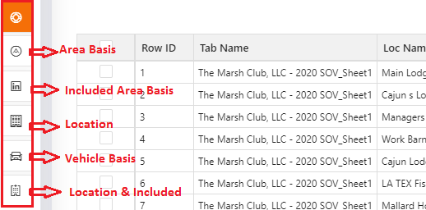

User can select the proration option based on his/her requirement. The application supports below proration types:

* **Area Basis**  : When a group of locations are given in original schedule and the values have been given in the first location, in that case we must distribute the values given in first location to the remaining locations.

By clicking this icon, the Area proration performed on RM Template and data get refreshed after that.

* **Location Basis** **:** Any location which is not geocoded, is distributed among other locations of same Division, State, Country and Account.

By clicking this icon, the Location basis proration performed on RM Template and data get refreshed after that.

* **Included Area Basis **: Consolidated value of the locations with comments "included above “, “incl. abv”, “including A” etc., in coverage is to be prorated against locations with same address on floor area basis on the complete schedule.

By clicking this icon, the Included basis proration performed on RM Template and data get refreshed after that.

* **Duplicate Locations (Vehicle) :** At any location, value of a building as well as a vehicle is provided, then duplicate location will be made for vehicle since it has an occupancy and construction different from that of the building.

By clicking this icon, a popup will appear to ask a column name of vehicle data on which you want to perform vehicle proration. The vehicle data loaded at the time of Import SOV. After selecting the column and click on OK the vehicle proration performed and duplicate locations will be added to RM Template based on unique postal codes.

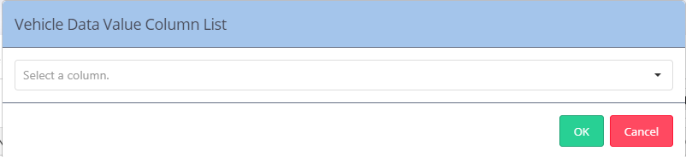

* **Include & Locations :** Perform both Included Basis and Location Basis.
* **Blanket** **:** Sometime user needs to prorate a blanket coverage within any account or within some location of the account. So, user can select desired set of locations and then click on blanket proration. By default, if no location is selected, values will be prorated across all the locations.

By clicking this icon, a popup will appear to ask a blanket value to be prorated and a coverage column on which proration will happen.

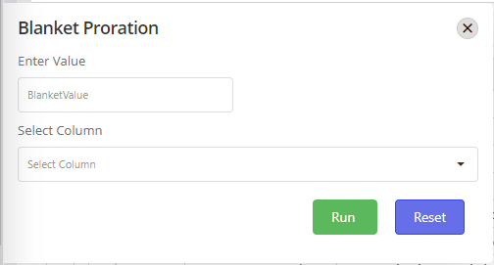

Once user will enter the blanket value, select the coverage column and click on Run button, then the blanket value will be prorated into the selected locations as per below coverage column rule.

1. Building: The blanket value will be prorated into the selected location based on Floor area of the location.
2. Content: The blanket value will be prorated into the selected location based on building value of the location.
3. BI: The blanket value will be prorated into the selected location based on PD (building + Content) of the location.
4. Others: The blanket value will be prorated into the selected location based on Floor area of the location.

* **Pipeline** **:** In some cases, when we have location name having pipeline description, then duplication of locations will happen at postal code level and values are placed in building. For all unique postal code of the state having pipeline description in Loc Name, duplicate location will be generated, and the building value will be equally prorated into these duplicate locations. In case area code is not mapped, the duplicate location will be generated for all unique postal code of the account.
* **IFM** **:** For IFM accounts, if the coverage values are given under column ‘Property Damage’, then we need to split those values into Building and Content based on the corresponding occupancy of the account. Breakup ratio for any occupancy can be provided under configuration. If for any occupancy breakup ratio is not provided, then 100% PD value will be moved into building.
* **Stock** **:** In some cases, duplication of locations will happen with values under stock need another mapping for stock apart from content and address and modifiers same as the original locations.
* **Construction & Occupancy** **:** In some cases, user need to create duplication of locations with same details as original location. By clicking this icon, a popup will come to select number of duplicate locations you want to create. Once selected then those number of duplicate locations will be generated with same details except coverage. Coverage will be 0 for these duplicate locations.

#### Geocoding

Select Geocoding [] option from left-hand menu of application. By clicking this icon, the geocoding page will open.

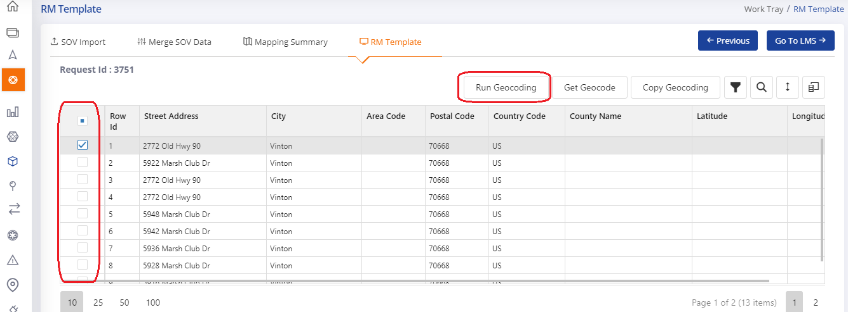

* User can select the multiple locations to run the geocoding.
* After selecting the locations User make a click on **Run Geocoding** button to submit the job on Geocoding server. User can wait for some time and make click on **Get Geocode** button.
* If geocoding job is not yet complete, then user get an information message.
* By clicking on Get Geocode button the geocode results added to last on the page. User can review them and select the results whom he/she wants to copy to RM Template.

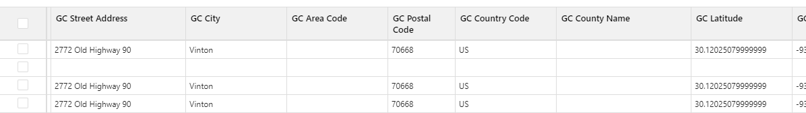

* Once user select the locations to copy the Copy Geocoding button get visible. Once User click on **Copy Geocoding** the location will be copied to RM Template and RM Template screen will be loaded.

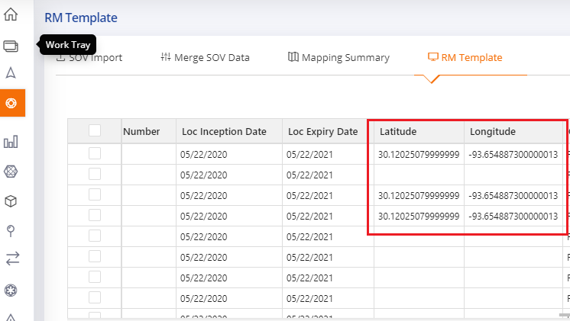

#### Polygon

Polygon feature is applicable for geocoded locations as it is needed Latitude and Longitude to draw a polygon and perform disaggregation of coverages based on selected points in polygon.

Select a location to disaggregate coverages and Select Polygon [] option from left-hand menu of application. By clicking this icon, the polygon page will appear with selected location on map.

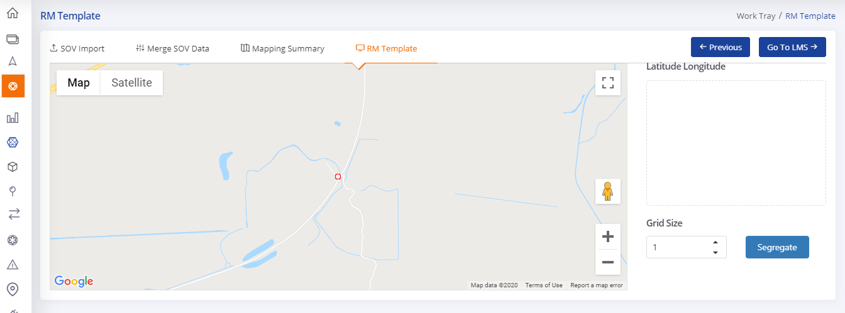

* User can draw the polygon across location and provide grid size to segregate data based on selected points. When user click on Segregate button the selected location values will be segregated to multiple locations selected in polygon. The original location coverage values will set to 0.

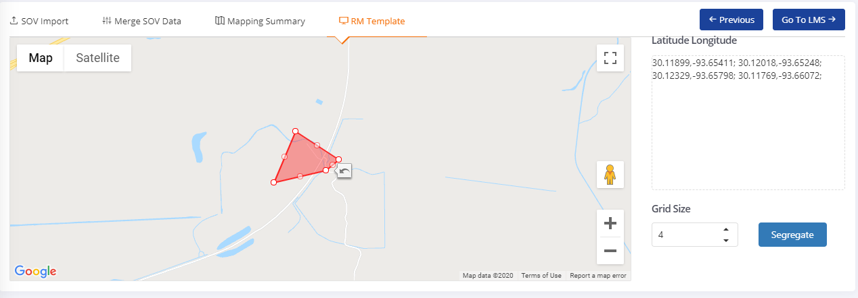

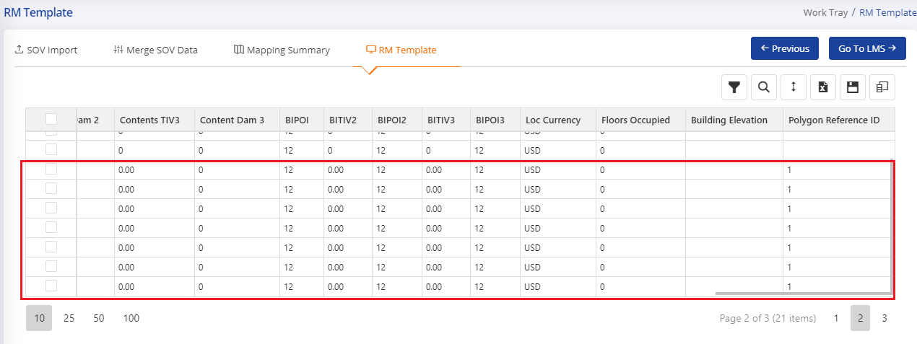

* If user does not select any location and make a click on Polygon icon the information message appears to select location to perform polygon.

#### Show locations on Map

Select Location on Map [] option from left-hand menu of application. By clicking this icon, the location on map page will appear with locations on map.

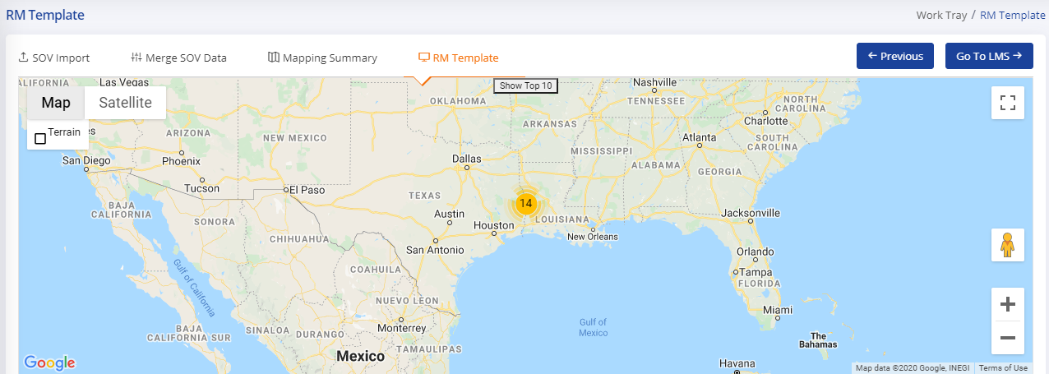

* User can see all locations or top 10 location based on TIV using “Show All ” or “Show Top 10”  option.
* Map display all the locations as a cluster. User can click on clusters to see the actual location place on map. Location marker will appear on the map.

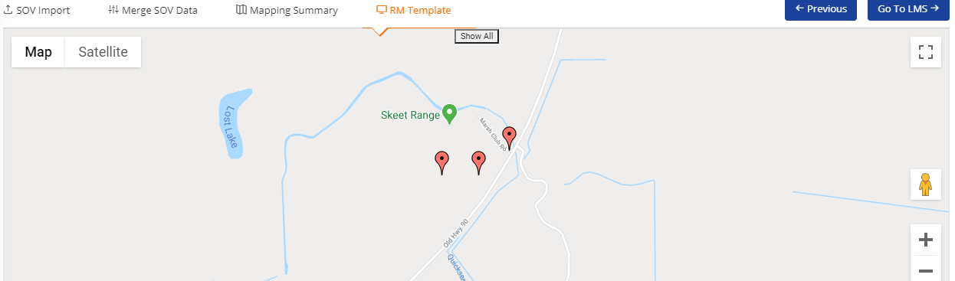

* By clicking on location marker, a popup will appear with all primary information of a location. User can update the primary information like Number of Stories, Occupancy Code, Constriction code and year built by seeing the actual location on map. User can make a click on Update button to persist the data on RM Template.

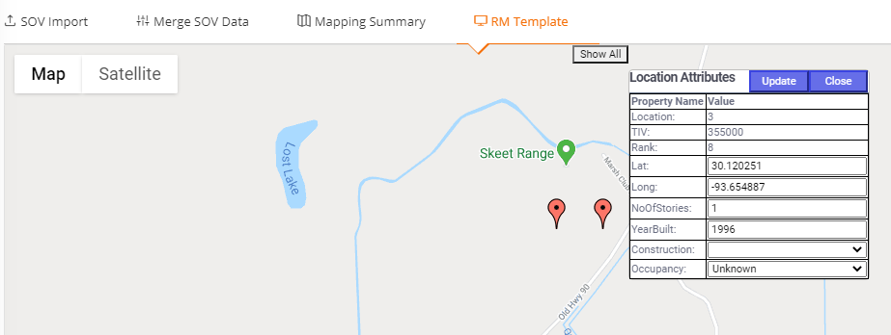

* User can also drag and drop the location to the right place. The corresponding latitude and longitude will get update in RM Template.
* User can also change the view of map as a Satellite view or 3D View.

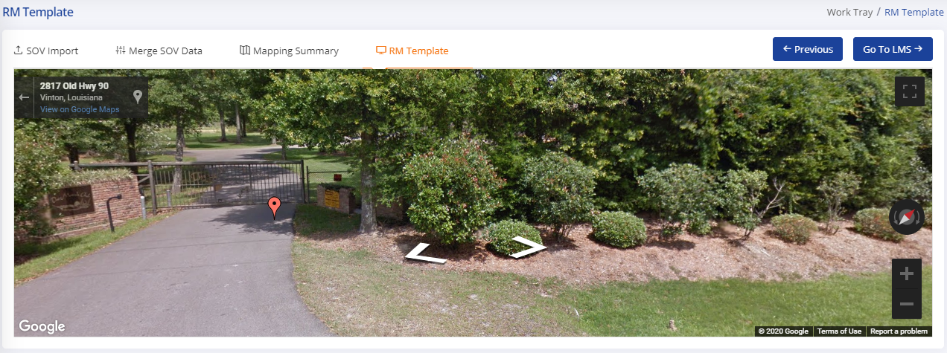

#### Map Modifier

User can map the cell description of modifiers to OED codes which are not auto mapped from repository. To map manually user either edit in the RM Template grid or make click on Map Modifier Option.

Select Map Modifiers [] option from left-hand menu of application. By clicking this icon, the Map Modifiers page will appear with different tabs.

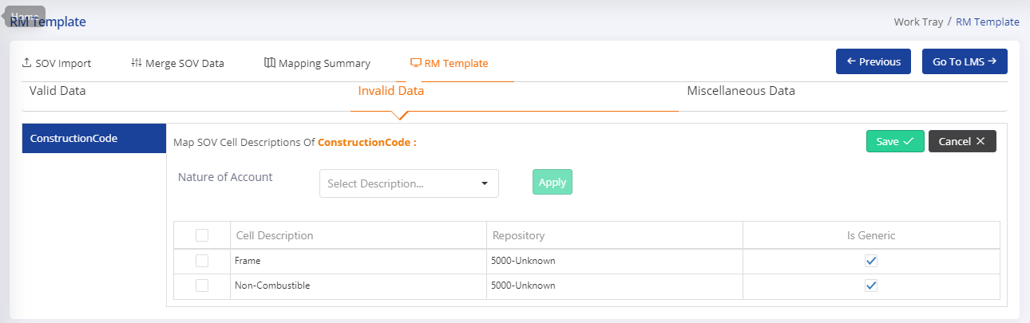

* By default, the Invalid Modifiers tab visible to the users. There is a list available for Modifiers (Occupancy, Construction and Secondary Modifiers) to choose individual category to map cell descriptions.
* Scrubbing tool leverages the Machine Learning to predict codes for Occupancy and Construction.
* According to application configuration, by default first predicted value is selected for occupancy and construction in case prediction value is greater or equals to the configured value.
* User can select the OED code from corresponding dropdown of SOV Cell description values.
* User can also apply the Nature of account for all or selected cell description by selecting the Nature of account code and make click on apply.

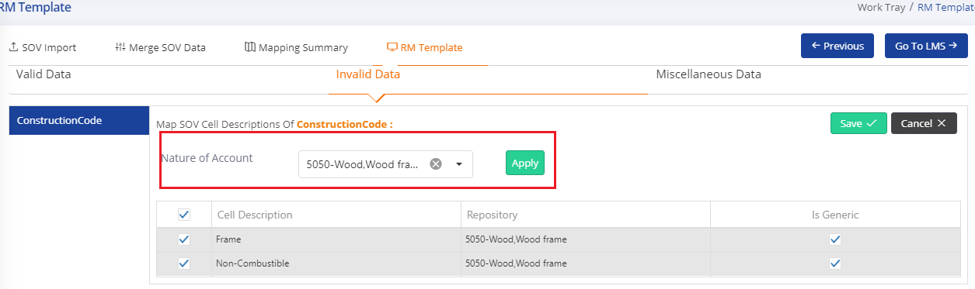

Once user selected the values and click on Save button the Modifiers cell description values replaced with selected code and description for corresponding categories.

* User can also review the valid data replaced during model generation from repository and default values.
* The list will appear for available primary and secondary modifiers. User can select each category and update the replaced code with new OED codes.

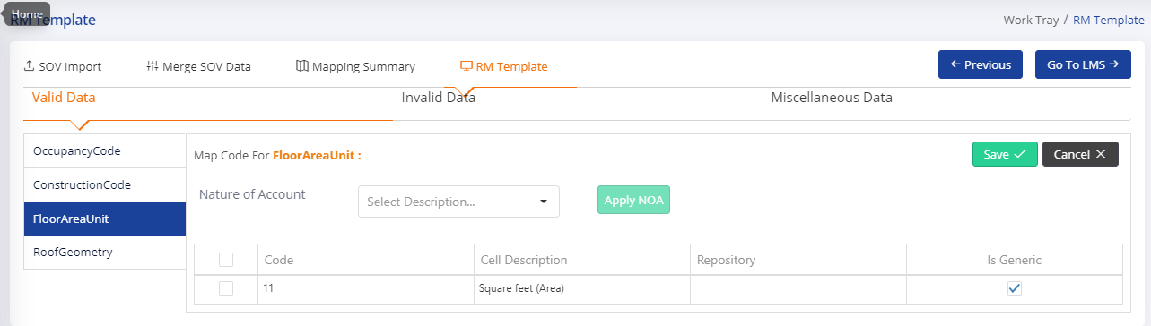

Once user selected the values and click on Save button the Modifiers cell description values replaced with selected code and description for corresponding categories.

* User can also review the Miscellaneous data for selected columns.
* The list will appear for selected columns. User can select each category and update the values and make click on Save button to replace the same on RM Template.

#### Data Compare

Select Data Compare [] option from left-hand menu of application. By clicking this icon, the Data compare page will appear with all OED columns list. Using this option user can compare the original SOV data with current state of data.

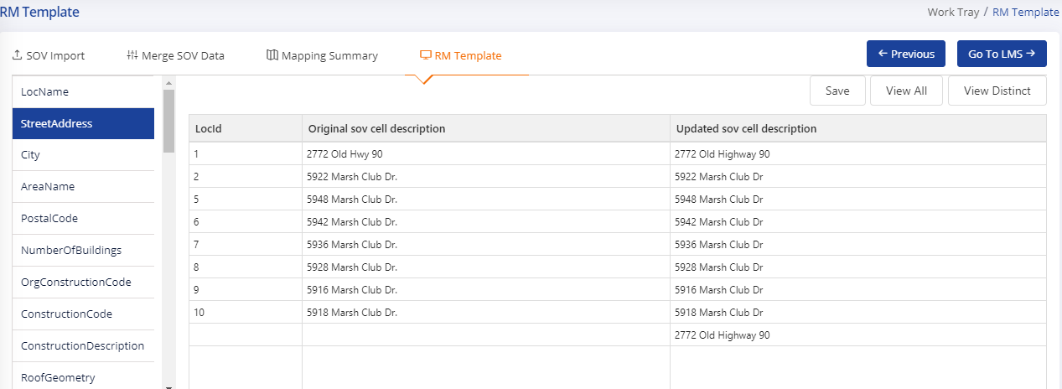

* User can select the column from the list, the corresponding data will be appeared on the right-side panel.
* By default, distinct values appear on the compare area. User can view all locations data using “View All” button.



* User can also update the values using edit and Save option. This option is useful in case user is not happy with the comparison results and he/she wants to update the values for same.

#### Data Validation (Sanity)

Select Sanity [] option from left-hand menu of application. By clicking this icon, the Sanity page will appear with all rules available in the system. The rule expression will display on hover of each rule so user can check the rule conditions as well.

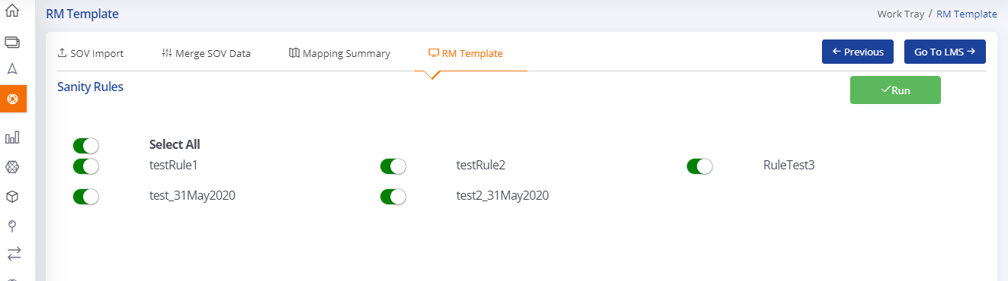

* User can select the rules which he/she wants to run on current RM template data.
* User can make a click on Run button to execute sanity. Once sanity is completed user get notified.
* User can see sanity errors using [] option from left hand menu of application. By clicking this icon, a pop-up will appear with Rule description and location numbers on which rules failed.
* User can export the errors into excel file using option “Export” on Popup.

#### Summary

Select Summary [] option from left-hand menu of application. By clicking this icon, the Summary page will appear to display reports on different COPE information like Construction, Occupancy, Year Built and more.

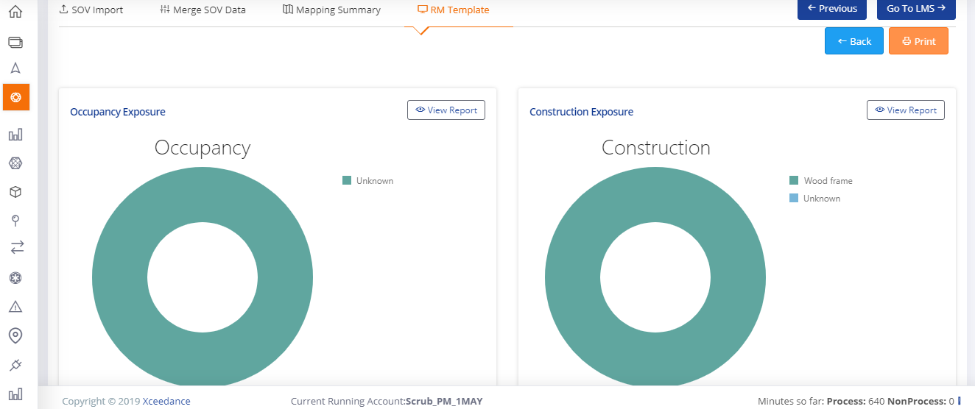

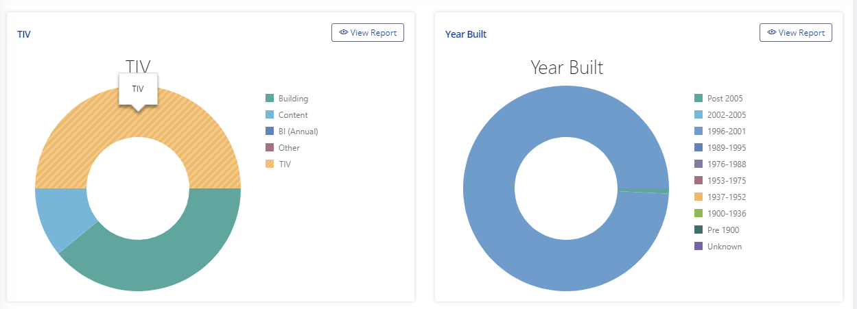

* User can print the summary report using “Print” button.

#### Third Party

Select Third Party [] option from left-hand menu of application. By clicking this icon, the Third-Party page will appear with available data provider list.

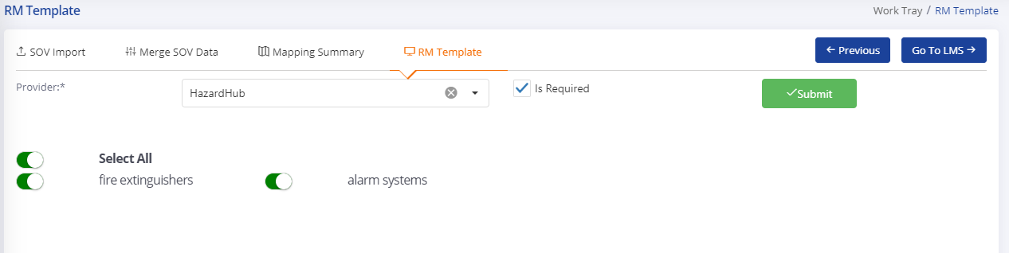

* User can select the providers from drop down. The page will get refreshed with available data options from that provider.
* User can select/unselect Is Required option to get default providers columns or not. By selecting this option, the third party required columns will be added to RM Template.
* The third party works on geocoded location and data enhancement attributes also dependent on those APIs.
* After selecting mapped columns and Required columns user can make a click on submit button. The third-party provider service returns the data enhancement attributes and appends to the RM Template.

#### RM Template Options

At the top right of the RM Template, several buttons help the user navigate through the location data in the RM Template. These icons allow the user to search for, filter and download Template. They also can customize how a user views the RM Template by adding and removing columns and full screen view.



* The following describes buttons that help the user maneuver through locations:

• **Clear All Filter**  **:** This option clear or remove all the applied filter on locations data in the RM Template.

• **Show Errors**  **:** This option shows the location highlighted with orange color in top in which primary modifier and secondary modifier column/data are not mapped with valid code.

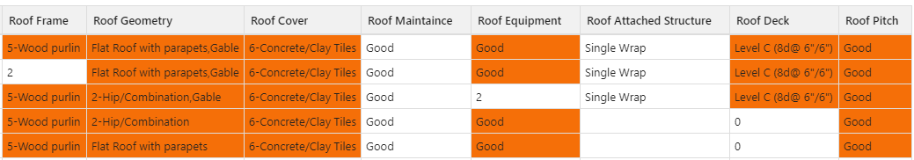

• **Column Filter**  **:** This option can filter locations in the RM Template by single or multiple values contained within a column. The user can use the filter look for groups of locations that have similar attributes.

• **Location Delete** **:** This option allows the user to delete a location from RM template. User can delete more than one location by selecting those location from RM template and then making a click on delete icon.

• **Column Search** **:** This option can search for specific values within columns. This button can be useful when looking for an attribute value for locations.

• **Export to Template**  **:** This option allows users to export the RM Template data to given formats. By clicking this icon, a popup will appear to ask LOB and Model Selection.

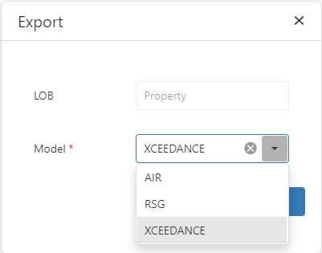

Once user select the appropriate options and click on Export, the Locations data export to the model template. User can open the exported file.



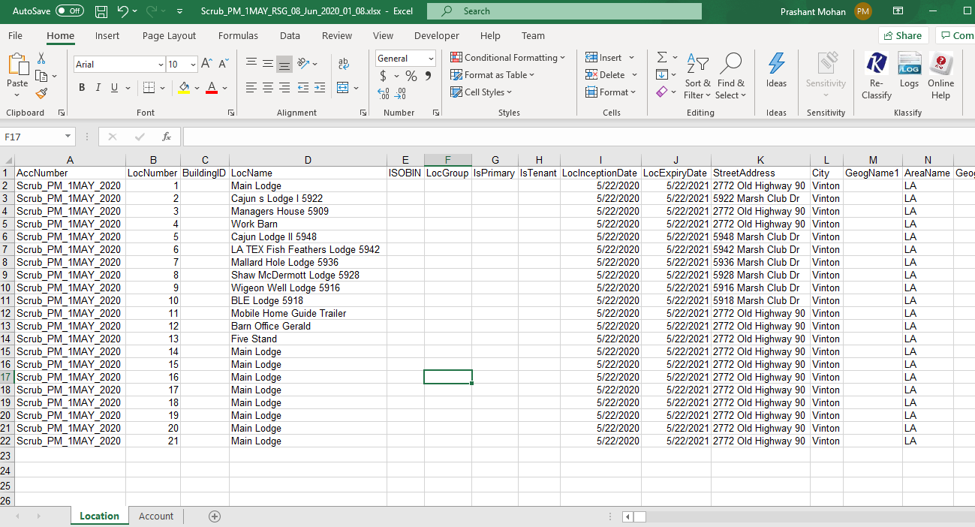

Before export the locations data, application performing the data validations on RM Template and in case data is not valid. It will not allow user to export the data.

• **Save**  **:** This option used to save edited data on RM Template. User can edit the RM Template at cell level and save the locations data using this option. On modifiers, a pop up will appear to select appropriate value for that cell.

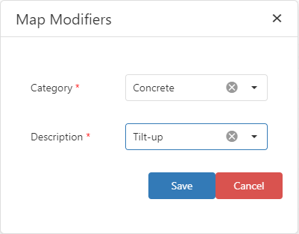

• **View Augmented Data**  **:** This option used to view some third-party API data of the location of RM Template. By making a click on this icon the Augmented data page will appear with available data provider list.

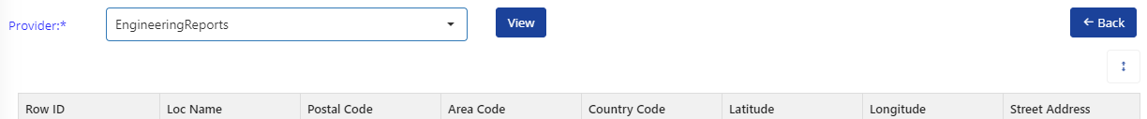

* + User can select the providers from drop down and then click on view icon the page will get refreshed with available data options from that provider.
  + To go back to RM template user can click on Back Button.

• **View Claim Details**  **:** This option is used to view the claim data against location of RM template. By making clicking on this icon, the claim details page will get appear.

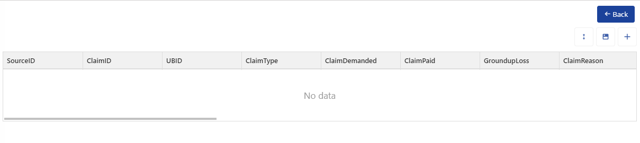

* + By click add a row (+) icon user can add claim details for a location. Once clicking a new row will be add into the grid and user can fill the data accordingly. Once done user can click on save icon to save the data.
  + To go back to RM template user can click on Back Button.

• **Find & Replace**  **:** This option allows the user to Find any specific word within any column and replace that word within that column. By clicking on this icon, a popup will appear to select the column in which user want to find and replace any word, enter any word to find and enter the word for replacing.

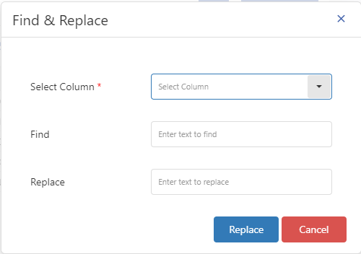

**Filter Column**  **:** This option allows the user to apply filter for specific values within column. Once user will click on filter icon, a filter popup will open to build an expression for filter out the peril financial data from the grid.

* + The Entity field will list out all the field or column of Location data exist on RM template. User can select any field from the drop-down to apply filter (find specific value within that column) on that field/column.

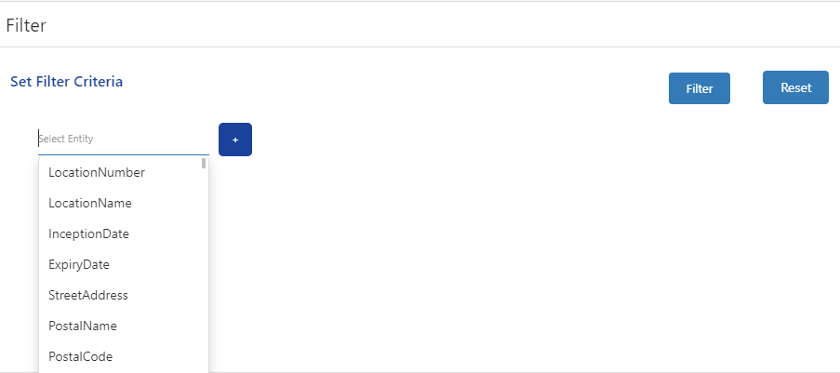

* + After selecting any field from entity drop-down, user must select any operator for that field to create a filter expression.

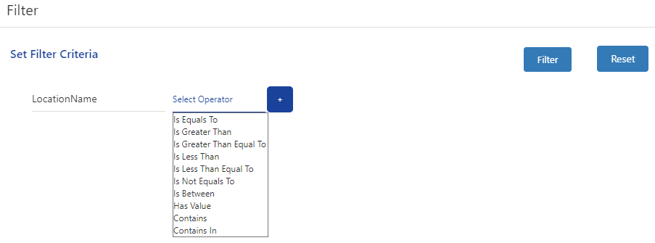

* + After selecting the any operator user must select the value from the right operand. User must enter any value for the selected field on which user want to apply filter.

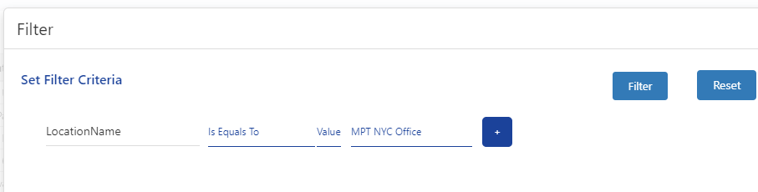

* + If user want to add more than one condition to apply, then user can add AND & OR condition by clicking on the plus icon from the end for the expression.

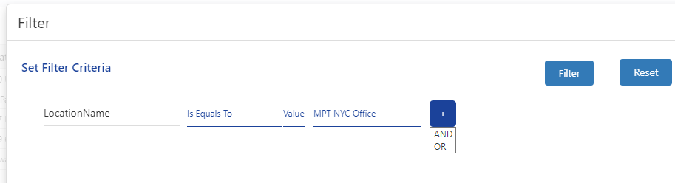

* + Once user will select any AND/OR condition a new entity field will be bind to add a new filter condition/expression.

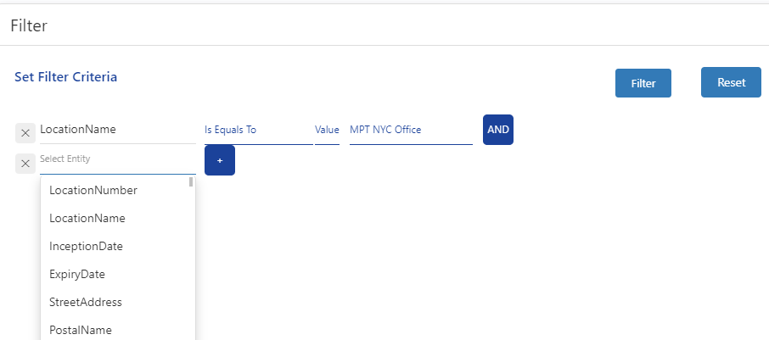

* + Once all build expression is complete for all the fields on which user want to apply filter, then user will click on Filter button. All the data as per build expression, will be show on bulk location update page.
  + If user want to modify any field from these filtered data, then user can use the update feature.

**Update Column**  **:** This option allows the user to bulk update the location data of the accounts. If user want to modification on filtered records/data, then user must first apply filter then go to update location page. If modification need into all location data, then filter is not needed.

Once user will click on this icon, an update popup will open. The Entity field will list out all the field of the location data. User can select any field from the drop-down to update.

To update/modify details of any field, user must create the build expression or update condition. First user must select the field, in which data needs modification, then in right operand user will select the value/reference.

* If user want to set any specific value of any field, must select value, and then enter the value of field to modify.

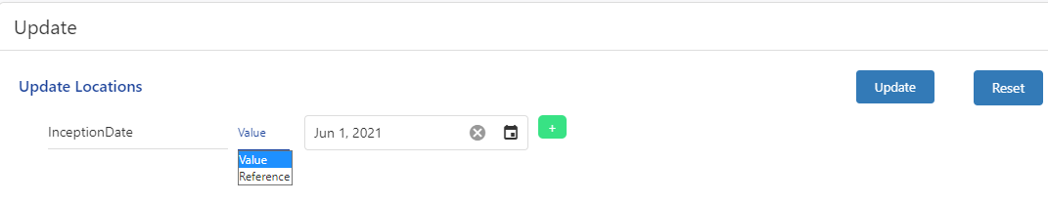

* If user want to copy any other field’s/column’s data into any field, then user must select the reference and then reference field/column.

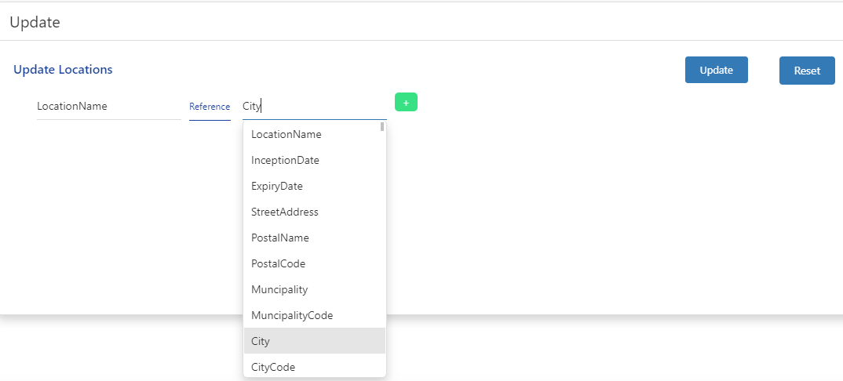

User can also update more than one field in one go by adding a new build expression  using this icon. Again, user must create the build expression of the new added field.

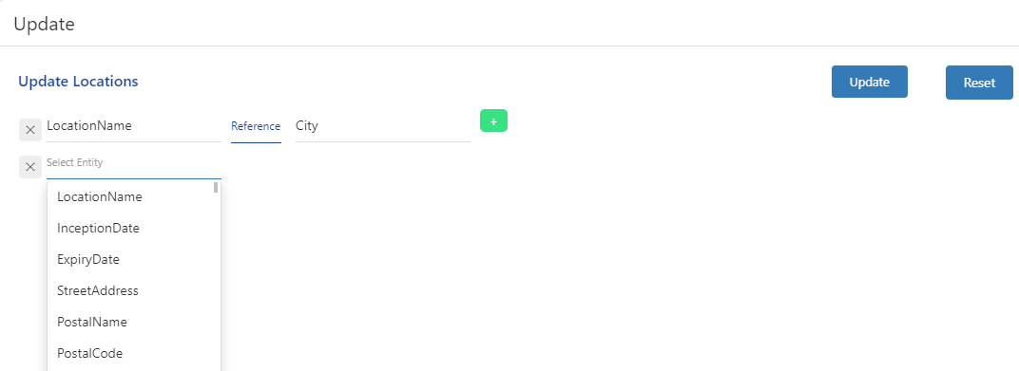

Once build expression is complete for all the field which need modification, then user will click on Update button. All the data as per build expression, will be update and same will reflect on location data grid of RM template.

**Undo Coverages**  **:** This option allows the user to undo the modification done on coverages column. By clicking on this icon, a popup will open to select the coverage column on which user want to perform undo coverage.

**Rename Column**  **:** This option allows the user to rename any existing column of RM template with any other OED’s column name. By clicking on this icon, a popup will appear to select the existing column name of RM template and to select the column name of OED into which the column will be renamed.

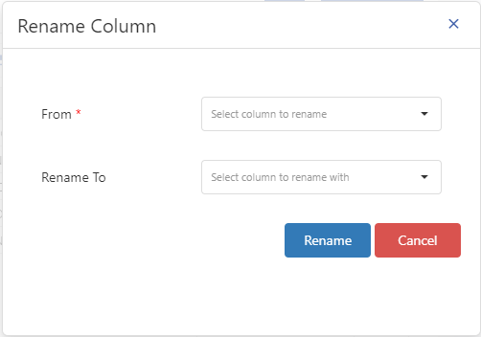

• **Move Column**  **:** This option allow user to move or copy the data of any column or columns within some another column or columns. The from and To column represent the source and target column respectively. User can perform the below operation on target column.

* **Copy:** This option allows the user to copy the data of source column into target column. This option will be enabled only when user have selected only one column into source. Target column may be one or more.
* **Priority:** This option allows the user to copy the data of source column into target column on priority basis. This function will work as below.
  + - If user has selected only one column in source but target may be one or more, then it will copy the data of source column only when there will be a null entry into target column.
    - If user has selected more than one column in source, then it will copy the data of first source column into target. If any row has null entry for first source column, then in that case it will copy the data of second source column into the target column.
* Concat: This option allows the user to concatenate the value of two or more source column and copy that value into the target column. This option will be enabled only when user has selected more than once source column.

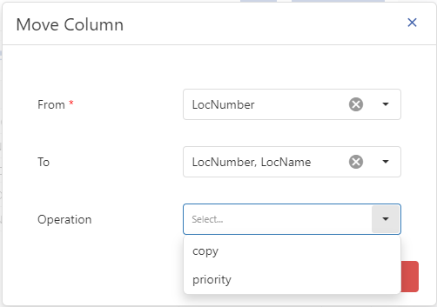

• **Delete Column**  **:** This option used to delete any unwanted column of RM Template. User can delete more than one column by using the checkboxes that appear when clicking on this icon and then making a click on Delete icon. The Selected column will be deleted from RM template.

* Users can customize their RM Template view using the following buttons:

• **Column Chooser ** shows or conceals any column of the RM Template by using the checkboxes that appear when clicking on this icon. Select or deselect the checkboxes to add or hide columns, respectively.

• **Expand screen ** maximizes the size of the RM Template to capture the full screen size of application. This will be helpful to visualize more data on his/her screen.

#### Submit to QA

Select Submit to QA [] option from left-hand menu of application. By clicking this icon, a pop up will appear to fill relevant information and submit the same for auditing process. Few information like No of location can be pre filled from CMR request.

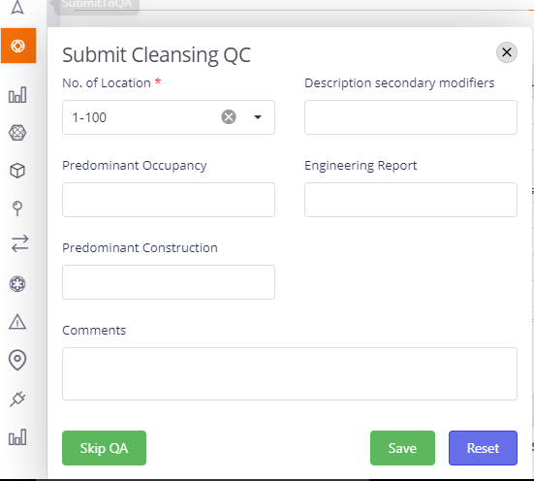

* User can also skip the auditing process using “Skip QA” button on the form. User can use this option when he/she is sure about the quality of SOV cleansing.
* By clicking on “Save” the request is submitted for QC Process.

## Default Features based on Role

### System Admin Features

The Admin have rights to perform below activities in system.

* Manage Users
  + Manage Team
* Manage Accounts
  + Create New CMR Request
  + Create New MRF Request
  + Check the running status and current user of all accounts
  + Assign accounts to Processor and Auditor
  + Insert account in Bulk
  + Cancel Account
  + Delete Account
  + Update Account
  + View Record Time
  + View Details
  + Add Remodel Request for completed accounts
  + Raise Query
  + Set Proposed date
  + Check documents
* Application Configuration
  + General application settings
  + Scrubbing Tool related settings
* Manage Query Logs
  + View/Edit all the queries raised by all users
  + Raise/Resolve the query
* Manage Rules for Scrubbing
  + Add/Delete/Update Rules
* Leave Management
  + View grid and calendar view to get details about members who are on leave
  + Add/Delete Leave request for any member
* Exposure Data Manager
  + Add Account Financials
  + Add Locations Using Scrubbing Tool
  + Add Account and Locations from application as well
  + Export to Model Agnostic format
* Task Configurations
  + Configure Workflow process for Quote and Bound
* Mail Configurations
  + Configure the mail service (SMTP/POP3/IMAP) for Query management
* Client Facing and Internal Reports

### Underwriter/Underwriter Assistant Features

The Underwriter and their assistant have rights to perform below activities in system.

* Manage Accounts
  + Create New CMR Request
  + Create New MRF Request
  + Check the running status and current user of all accounts
  + Cancel Account
  + Update Account
  + View Record Time
  + View Details
  + Add Remodel Request for completed accounts
  + Raise Query
  + Check documents
  + Scrubbing Tool related settings
* Manage Query Logs
  + Raise/Resolve the query
* Client Facing Reports

### Team/Unit Lead Features

The Unit Lead have rights to perform below activities in system.

* Manage Accounts
  + Create New CMR Request
  + Create New MRF Request
  + Check the running status and current user of all accounts
  + Assign accounts to Processor and Auditor
  + Insert account in Bulk
  + Update Account
  + View Record Time
  + View Details
  + Add Remodel Request for completed accounts
  + Raise Query
  + Set Proposed date
  + Check documents
* Manage Query Logs
  + Raise/Resolve the query
* Leave Management
  + View grid and calendar view to get details about members who are on leave
  + Add/Delete Leave request for any member
* Exposure Data Manager
  + Add Account Financials
  + Add Locations Using Scrubbing Tool
  + Add Account and Locations from application as well
  + Export to Model Agnostic format
* Client Facing and Internal Reports

### Processors Features

The Processors have rights to perform below activities in system.

* Manage Accounts
  + Create New CMR Request
  + Create New MRF Request
  + Check the running status and current user of all accounts
  + View Record Time
  + View Details
  + Add Remodel Request for completed accounts
  + Raise Query
  + Set Proposed date
  + Check documents
* Manage Query Logs
  + Raise/Resolve the query
* Leave Management
  + View grid and calendar view to get details about members who are on leave
  + Add/Delete Leave request for any member
* Exposure Data Manager
  + Add Account Financials
  + Add Locations Using Scrubbing Tool
  + Add Account and Locations from application as well
  + Export to Model Agnostic format
* Client Facing and Internal Reports

### Auditors Features

The Auditors have rights to perform below activities in system.

* Manage Accounts
  + Create New CMR Request
  + Create New MRF Request
  + Check the running status and current user of all accounts
  + View Record Time
  + View Details
  + Add Remodel Request for completed accounts
  + Raise Query
  + Set Proposed date
  + Check documents
* Manage Query Logs
  + Raise/Resolve the query
* Leave Management
  + View grid and calendar view to get details about members who are on leave
  + Add/Delete Leave request for any member
* Exposure Data Manager
  + Add Account Financials
  + Add Locations Using Scrubbing Tool
  + Add Account and Locations from application as well
  + Export to Model Agnostic format
* Client Facing and Internal Reports